Writing

Our writing leader is Mrs Wilding.

INTENT
At the heart of our curriculum are our school curriculum drivers – Diversity, Responsibility and Opportunities. The drivers shape our curriculum, bring about the aims and values of our school, and respond to the needs of our community. Here at Moat Farm Junior School, we aim to deliver a high-quality education in writing that will allow our pupils to speak and write fluently so that they can communicate their ideas and emotions to others. We strive to ensure that our pupils enjoy and understand language, especially vocabulary which will support their writing, in order to enhance the effectiveness of their writing as well as their competence.

Our curriculum for writing aims to ensure that all pupils can:
1. Transcription
Spelling:
• Use a range of prefixes and suffixes and understand how to add them.
• Spell homophones correctly by choosing the most suitable spelling.
• Spell some words with ‘silent’ letters.
- Place the possessive apostrophe accurately in words with regular plurals.
- Use a dictionary to check spellings, as well as a thesaurus to identify synonyms.

Handwriting:
• Use the diagonal and horizontal strokes that are needed to join letters and understand which letters, when adjacent to one another, are best left unjointed.
- Increase the legibility, consistency and quality of their handwriting to a point where they write legibly, fluently and with increasing speed.
- Choose the writing implement that is best suited for a task.

Composition:
• Discuss writing similar to that which they are planning to write in order to understand and learn from its structure, vocabulary and grammar
• identify the audience for and purpose of the writing, selecting the appropriate form ensuring that they select appropriate grammar and vocabulary.
• Compose and rehearse sentences orally (including dialogue)
• Progressively build a varied and rich vocabulary and an increasing range of sentence structures, developing initial ideas by drawing upon reading.
• Organise paragraphs around a theme using a wide range of devices to build cohesion within and across paragraphs.
• Create settings, characters and plots in narrative forms of writing after analysing how authors have developed characters and settings in texts that they have read, listened to or heard performed (including integrating dialogue to convey character and advance the action).
• Use organisational and presentational devices, in non-narrative material, to structure and guide the reader.
• Assess the effectiveness of their own and others’ writing and suggest improvements (including grammar and vocabulary to improve consistency and clarify meaning).
• Consistently use the correct tense throughout a piece of writing.
• Use the correct subject and verb agreement when using singular and plural, distinguishing between the language of speech and writing and choosing the appropriate register.
• Proof-read for spelling and punctuation errors.
• Read aloud their own writing, to a group or the whole class, using appropriate intonation and controlling the tone and volume so that the meaning is clear.

Vocabulary, spelling and grammar:
• Use a wide range of conjunctions to develop their sentences beyond a main clause.
• Use the present perfect form of verbs in contrast to the past tense as well as use passive verbs to affect the presentation of information in a sentence.
• Use modal verbs or adverbs to indicate degrees of possibility
• Choose nouns or pronouns appropriately for clarity and cohesion and to avoid repetition.
• Use relative clauses beginning with who, which, where, when, whose, that or with an implied (i.e. omitted) relative pronoun
• Use expanded noun phrases to convey complicated information concisely
• Recognise vocabulary and structures that are appropriate for formal speech and writing, including subjunctive forms
• Use conjunctions, adverbs and prepositions to express time and cause.
• Use fronted adverbials (including using commas after fronted adverbials).
• Use commas to clarify meaning or avoid ambiguity in writing.
• Use hyphens to avoid ambiguity.
• Use brackets, dashes or commas to indicate parenthesis.
• Indicate possession by using the possessive apostrophe with plural nouns.
• Punctuate direct speech.
• Use semi-colons, colons or dashes to mark boundaries between independent clauses.
• Use a colon to introduce a list.
• Use and understand the grammatical terminology accurately and appropriately in discussing their writing.

IMPLEMENTATION
Here at Moat Farm, we believe writing is key for academic success and so we take a holistic approach to the teaching of writing, providing pupils with:

• A text-based learning approach, which is at times linked closely to the wider curriculum. This approach allows pupils to develop their skills of reading as a writer and writing as a reader.
• Texts that expose pupils to a wide range of genres and sub- genres to write from, which provide pupils with the opportunity to demonstrate their understanding and thinking around these, as well as allowing them to exercise a formal and informal tone.
• Texts that allows pupils to explore situations of dilemma, consider a range of emotions, as well as write from different perspectives.
• Daily English lessons on the timetable to give time to developing the craft of writing.
• A high-quality education where basic skills are a high priority - bridging gaps as quickly as possible.
• Learning journeys that allow pupils to explore, rehearse, discuss and write their ideas down before embarking upon a piece of writing.
• Planning which is personalised to the need of pupils, challenging them, building upon prior skills that have been embedded as well as bridging any gaps that may have not yet been secured.
• Opportunities to apply their writing skills in other subjects across the curriculum outside of the dedicated English lessons (through for example: Topic, Science and R.E).
• The opportunity to engage with authors (internally and externally of the school premises).
• The opportunity to write for a range of purposes and audiences through the use of external writing competitions, where pupils are able to apply their learning.
• The most recent CPD in writing to ensure that children’s writing outcomes are age related and progressive.
- Opportunities to enter various writing competitions throughout the year, such as Spooky Saga.

IMPACT
At Moat Farm Junior School, we want our writing provision to impact our children in the ways listed below. We want our children to become literate pupils. In order to achieve that, our children will show:

• The ability to write fluently and with interesting detail on a number of topics and genres throughout the curriculum.
• A vivid imagination which makes readers engage with and enjoy their writing.
• A highly developed vocabulary and an excellent knowledge of writing techniques to extend details or description.
• Well-organised and structured writing, which includes a variety of sentence structures.
• Excellent transcription skills that ensure their writing is well presented and punctuated, spelled correctly and neat.
• A love of writing and an appreciation of its educational, cultural and entertainment values.

We monitor the impact of our writing provision through half termly whole school pupil perceptions, termly assessments, in-house and external moderation, lesson observations and monitoring of English books.

Our children were lucky enough to have had a visit from local published author Mike Gayle (http://mikegayle.co.uk/about-me):
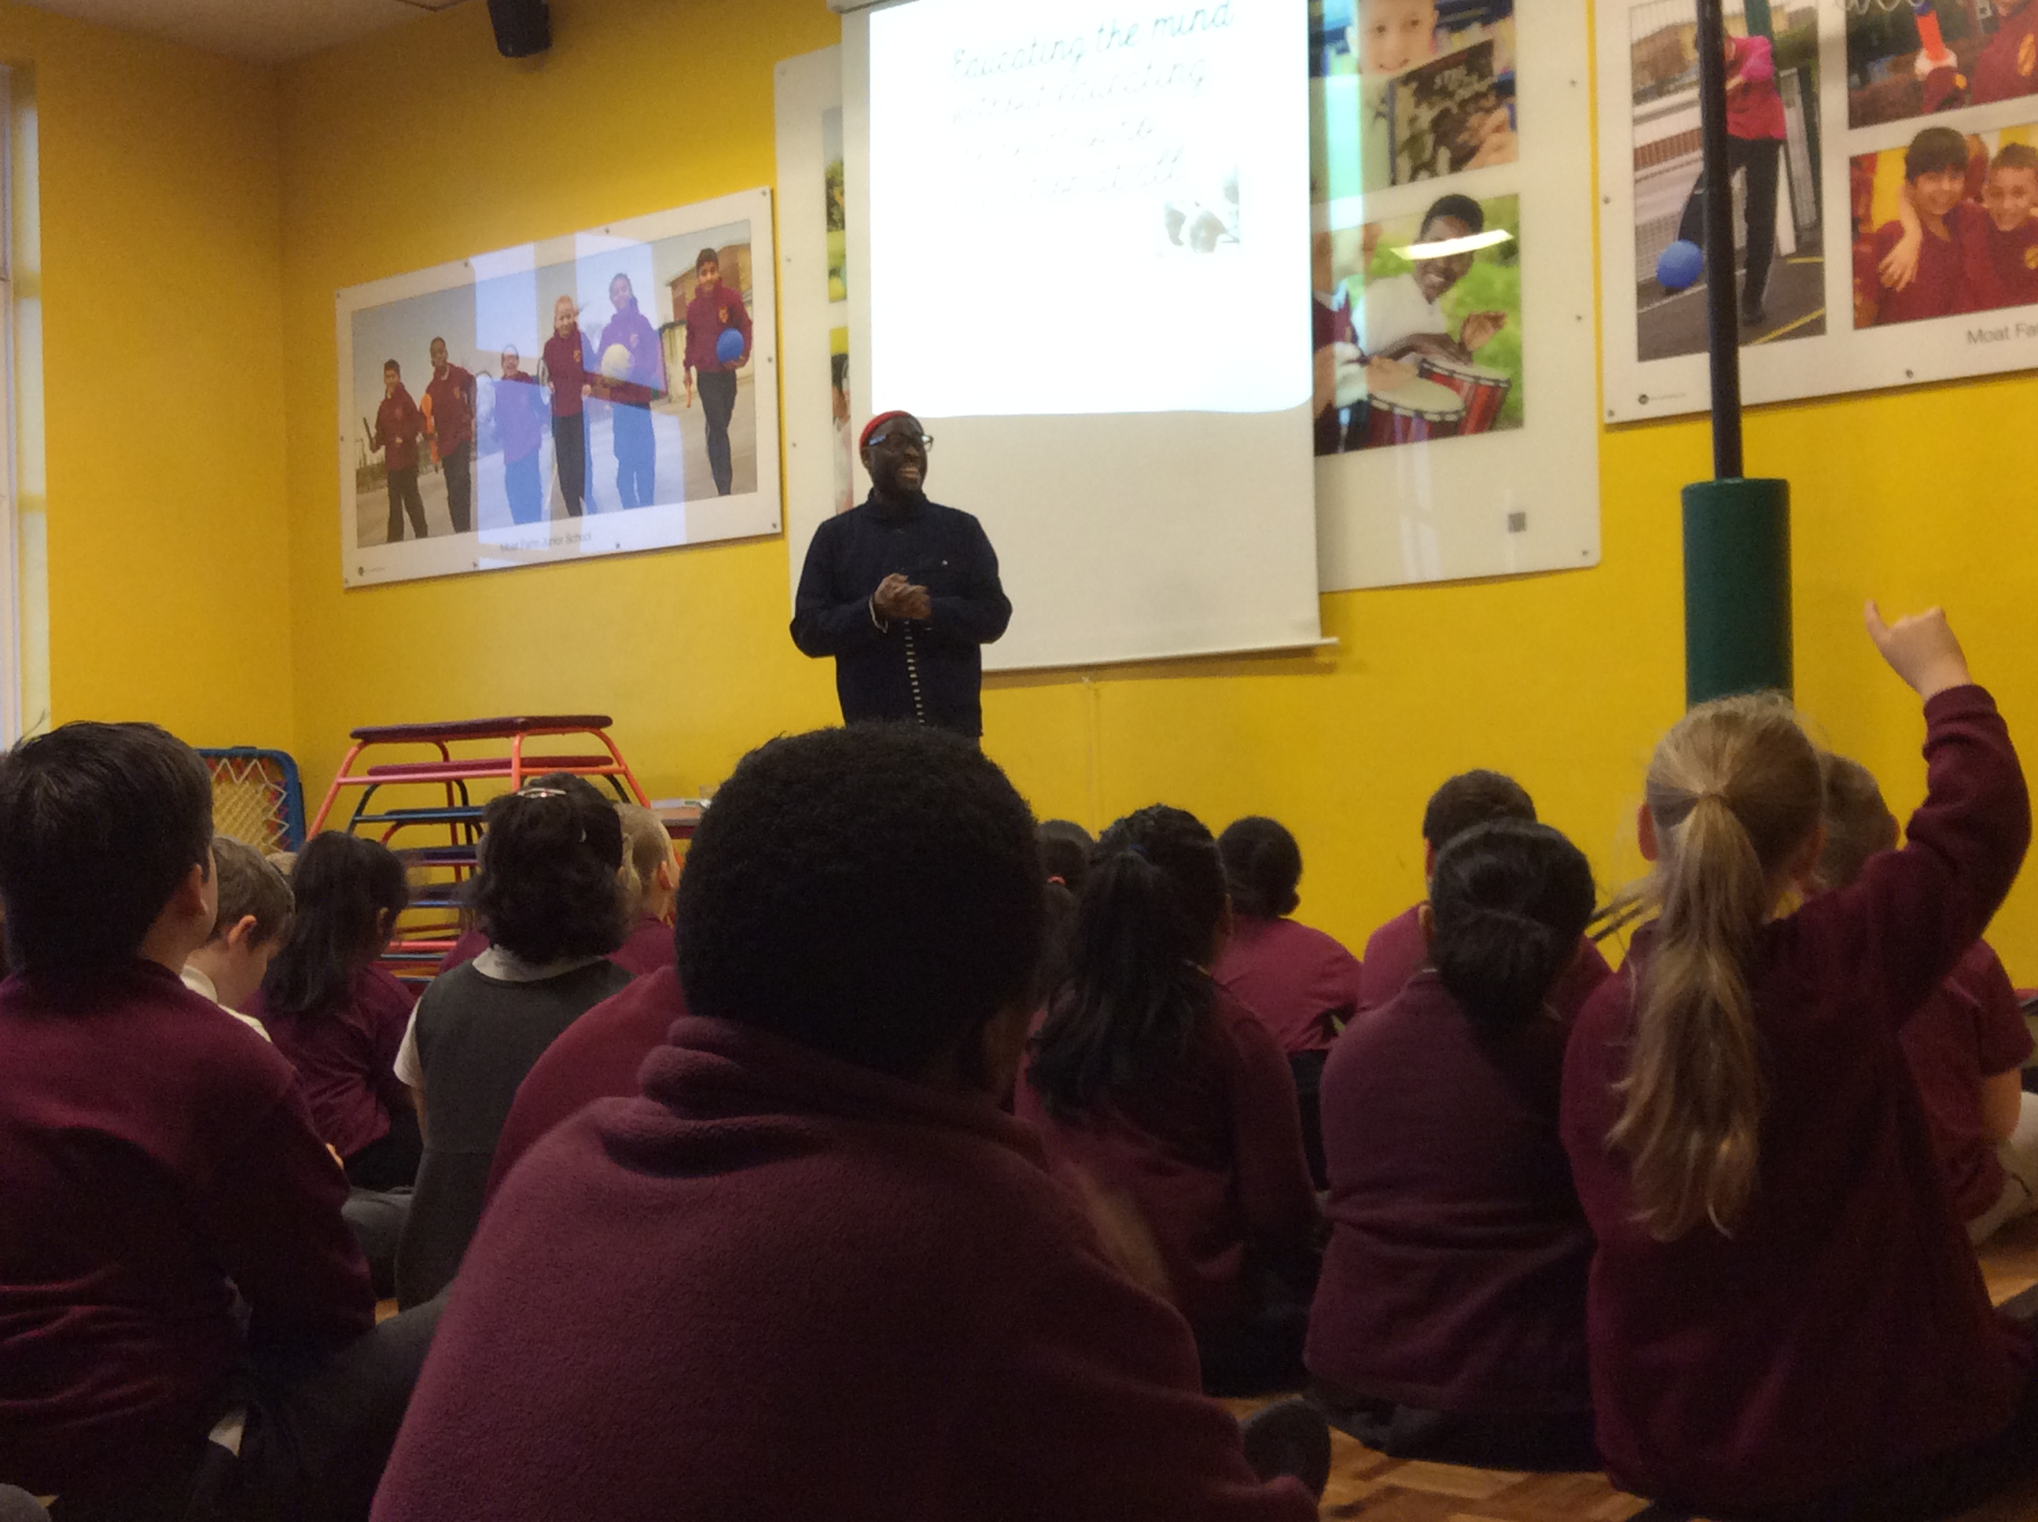
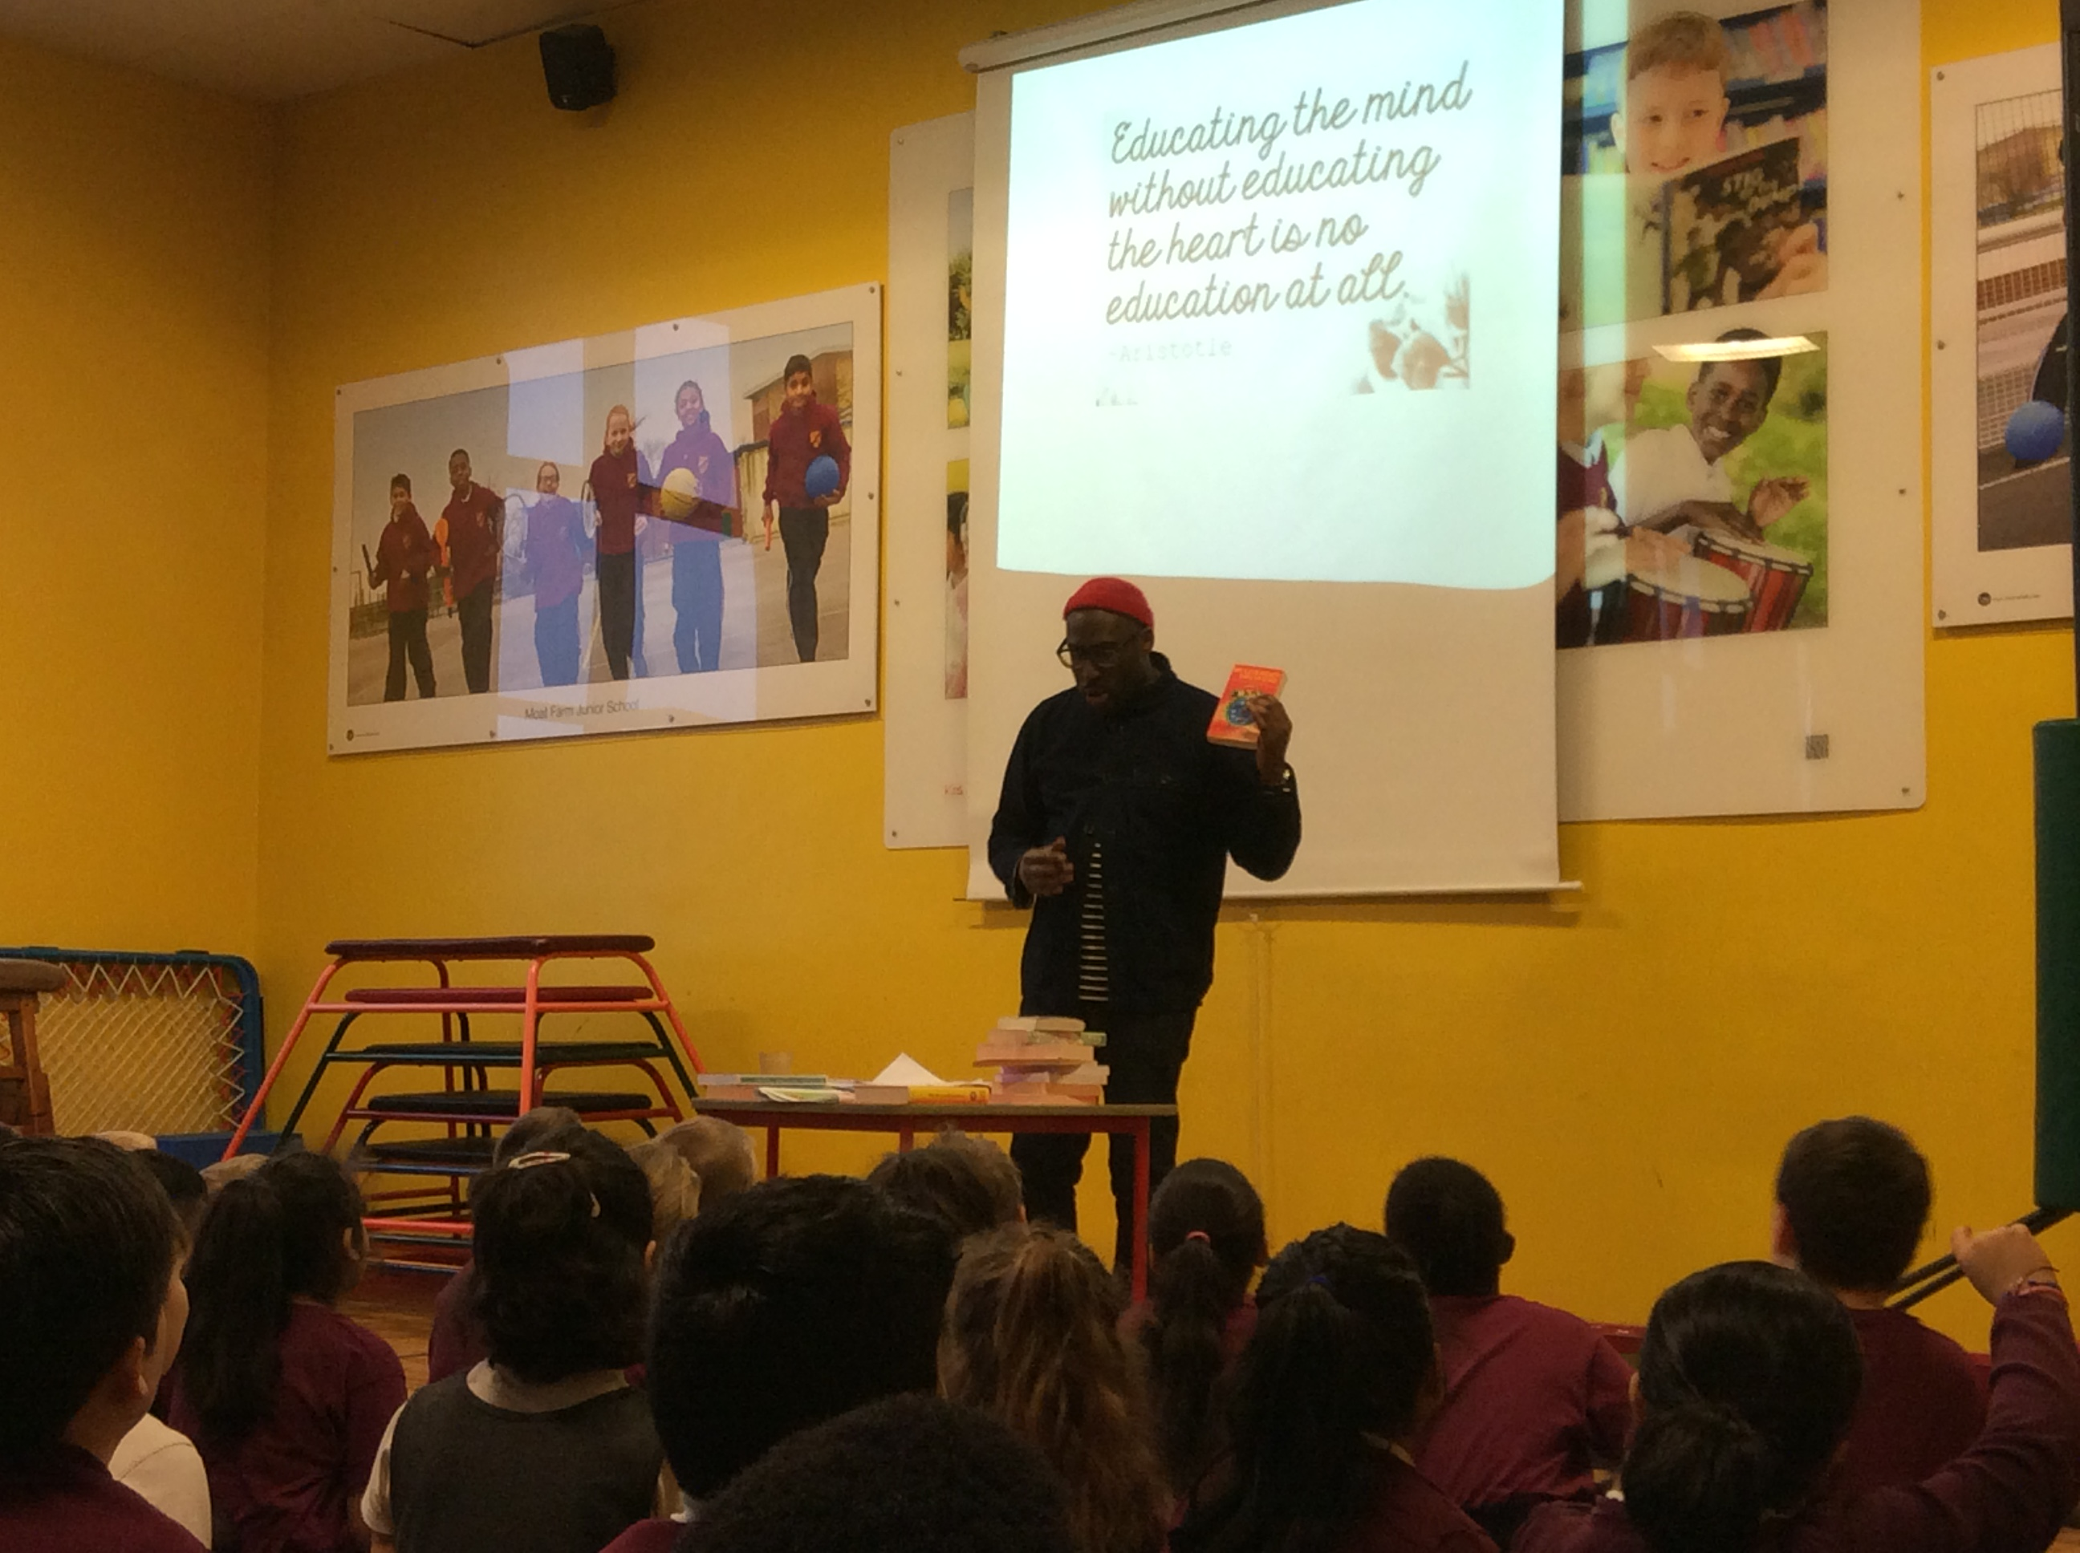

Mike Gayle was born and raised in Birmingham. After graduating from Salford University with a degree in Sociology Mike moved to London with ambitions of becoming a music journalist. This didn't happen however and following a slight detour in his five-year plan he ended up as an agony uncle for teenage girls' magazine Bliss before becoming Features Editor on the now much missed Just Seventeen. Since those early days Mike has written for a variety of publications including The Sunday Times, The Guardian and Cosmopolitan.
Mike became a full-time novelist in 1997 following the publication of his Sunday Times top ten bestseller My Legendary Girlfriend, which was hailed by The Independent as 'Full of belly laughs and painfully acute observations,' and by The Times as 'A funny, frank account of a hopeless romantic.'
To date Mike is the author of twelve novels including Mr Commitment, Turning Thirty and Wish You Were Here. His books have been translated into over thirty languages.

