Science

Our Science leader is Mr Kettle.

INTENT
At the heart of our curriculum are our school curriculum drivers – Diversity, Responsibility and Opportunities. The drivers shape our curriculum, bring about the aims and values of our school, and respond to the needs of our community. Here at Moat Farm Junior school, a high-quality science education provides the foundations for understanding the world. Science has changed our lives and is vital to the world’s future prosperity, and all pupils at Moat Farm Junior School are taught essential aspects of the knowledge, methods, processes and uses of science. Children are encouraged to understand how science can be used to explain what is occurring, predict how things will behave, and analyse causes.

The national curriculum for science aims to ensure that all pupils:

- develop scientific knowledge and conceptual understanding through the specific disciplines of biology, chemistry and physics
- develop understanding of the nature, processes and methods of science through different types of science enquiries that help them to answer scientific questions about the world around them
- are equipped with the scientific knowledge required to understand the uses and implications of science, today and for the future.

Whilst at Moat Farm, children are encouraged to be independent and collaborative scientific investigators by their involvement in exciting practical investigations. Children are encouraged to be creative and taught to understand fair testing through designing their own experiments. Pupils observe, explore and ask questions about living things, materials and physical processes. They evaluate evidence and consider whether tests or comparisons are fair. Children are taught to use reference materials to find out more about scientific ideas. They share their ideas and communicate them using scientific language, drawings, charts and tables.
Pupils are taught to describe associated processes and key characteristics in common language, but are also taught to be familiar with, and use, technical terminology accurately and precisely. They are encouraged to apply their mathematical knowledge to their understanding of science, including collecting, presenting and analysing data.

IMPLEMENTATION
Schools have a statutory responsibility to deliver science to all pupils. Here at Moat Farm Junior School, we ensure that sufficient time is given in order to enable pupils to meet the expectations set out in the National Curriculum, ensuring that the curriculum is coherent and shows progression, particularly across transitions between key stages. A minimum of 5% of curriculum time is allocated to science; this equates to one hour per week. In addition to this, we also take our children on various trips, such as The Big Bang UK Young Scientists & Engineers Fair, to further enhance their learning.

Science planning at Moat Farm Junior School follows the National Curriculum’s programmes of study and is personalised to the needs of our children; it challenges them and builds on previous learning. To further support this, teachers plan activities within each science lesson following our ‘basic, advancing and deep’ structure, making science accessible to all pupils.

Our whole-school science overview not only ensures that children learn through exploring and talking about their ideas; asking their own questions about scientific phenomena; and analysing functions, relationships and interactions, but that there is also progression in learning throughout the year groups.
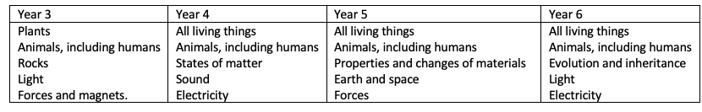

IMPACT
- At Moat Farm Junior School, we want our science provision to impact our children in the ways listed below. We want our children to become independent and collaborative scientific investigators. In order to achieve that, our children will show:

- An outstanding level of science understanding and knowledge.
- Independence; they can ask their own questions about what they observe and make some decisions about which types of scientific enquiry are likely to be the best ways of answering them, including observing changes over time, noticing patterns, grouping and classifying things, carrying out simple comparative and fair tests and finding things out using secondary sources of information.
- The ability to draw conclusions based on their data and observations, use evidence to justify their ideas and use scientific language, to talk about and write about their findings.
- An understanding of more abstract scientific ideas and a recognition of how these ideas help them to understand and predict how the world operates.
- An ability to recognise that scientific ideas change and develop over time.
- A deep understanding of a wide range of scientific ideas.

We monitor the impact of our science provision through half termly whole school pupil perceptions, termly assessments, lesson observations and monitoring of science books.

The Big Bang Fair
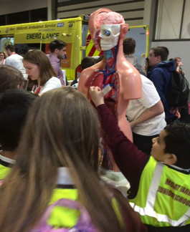
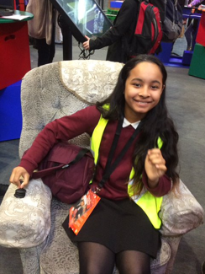
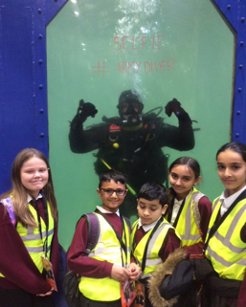
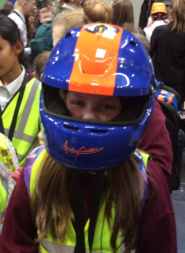
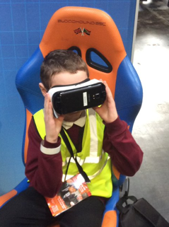

The Big Bang UK Young Scientists & Engineers Fair is the largest celebration of science, technology, engineering and maths (STEM) for young people in the UK. It is an award-winning combination of exciting theatre shows, interactive workshops and exhibits and careers information from STEM professionals.
The Fair gives young people the chance to hear from inspiring engineers and scientists from some of the UK’s biggest companies and find out about the opportunities available in STEM. Visitors can join in and discover virtual reality, medicine, marine biology, film and TV, space exploration, explosive chemistry, crime-solving, robots, computer coding, microscopic bugs, giant trucks and more.
We selected children from all year groups to take on this trip. They represented our school perfectly and took part in various activities; from going into an ambulance and helicopter, to taking part in engineering workshops, which included building a bridge without a frame and cleaning single use plastics from the ocean.

