Maths - Friday 10th July
All the challenges are in this document – each one gets a bit more difficult so see how many you can do!
Complete your calculations below.
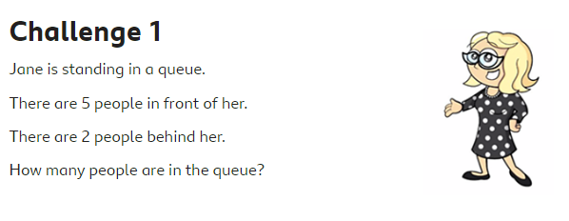
Answer =

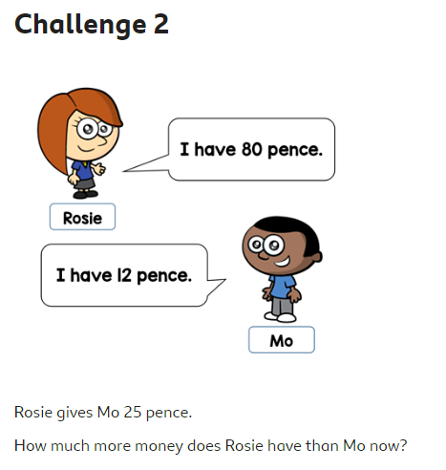
Answer =
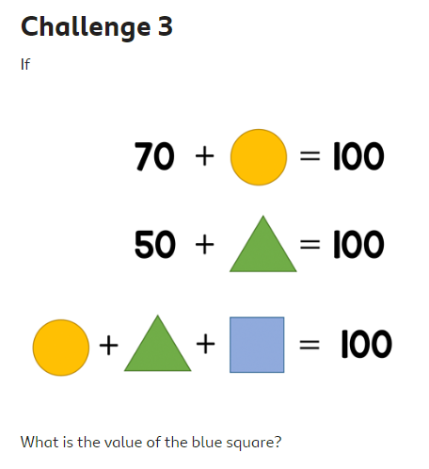
Answer =

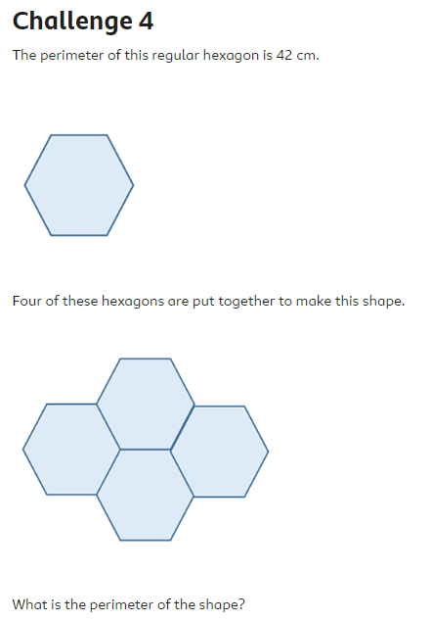
Answer =

