English – Friday 10th July

1. Story time
Read the two poems, Owl and The Sparrow.

Owl

Owl
Was darker
Than ebony
Flew through the night
Eyes like amber searchlights,
Rested on a post,
Feathers wind-ruffled,
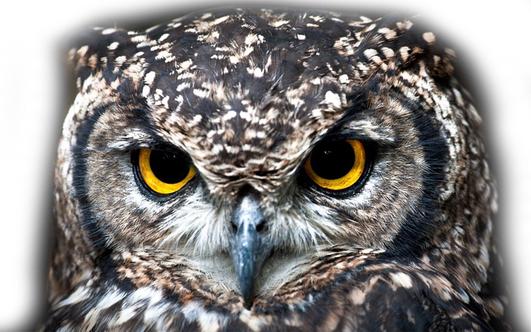
Stood stump still,
Talons ready to seize
And squeeze.

Owl
Was death
That swamped the fields,
For it flew through the dark
That tightened its knot,
That bandaged the hills
In a blindfold of fear.

Owl flew – who – who – who –

Pie Corbett
The Sparrow

I found a speckled sparrow
between the showers of rain.

He thought the window wasn’t there
and flew against the pane.

I picked him up and held him.
He didn’t stir at all.
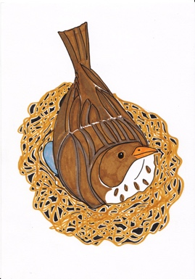
I hardly felt him in my hand,
he felt so soft and small.

I held him like a flower
upon my open palm.

I saw an eyelid quiver,
though he lay still and calm.

I never thought a bird so limp
could fly away so fast.

2. Answering Questions
Read the Questions about the two poems.
- Answer under the questions in the spaces provided.

Questions about Owl

Find and copy a simile that is used in the poem.

Alliteration is when several words in a row begin with the same sound (the big bad bird; a few fake flowers). Find and copy an example of alliteration in the poem.

Is Owl an example of rhyming verse or free verse? If you are not sure what free verse is, ask a grown up if you can look it up in a dictionary on online.

Suggest another word or words for:

flew:

ruffled:

bandaged:

Describe how the poem makes you feel.

Questions about The Sparrow
What has happened to the sparrow in the poem?

The Sparrow is an example of rhyming verse.
Copy down two pairs of rhyming words from the poem.
________________________________ and ___________________________________
________________________________ and ___________________________________

‘and flew against the pane.’ A pane is a sheet of glass. Write down a homophone for the word pane (see Day 2 if you need to check what a homophone is). Write a sentence with your word in it.

In your own words, explain how you think the sparrow in the poem is feeling.

How is the mood of The Sparrow different to that of Owl?

3. Stating preferences
Think about each of the poems.
- On My Favourite, say which one you prefer.
- Give as many reasons for your choice as you can.
- Use the conjunctions because, since and as to explain your reasons.

My Favourite of the two poems
because since as
Write below

