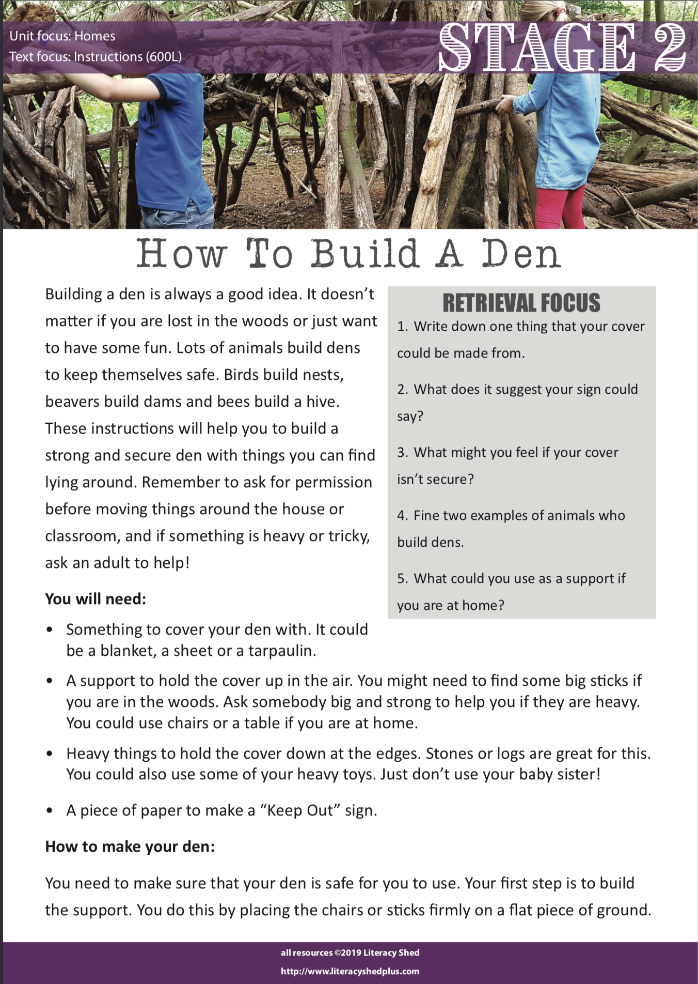

Retrieval focus
Write your answers in this space here

1.
2.
3.
4.
5.

ANSWERS

- Tarpaulin, blanket or sheet
2.‘Keep out’ sign
3.Cold if it’s a breezy day, get wet if it rains
4.Birds, beavers or bees
5.Table or chairs

