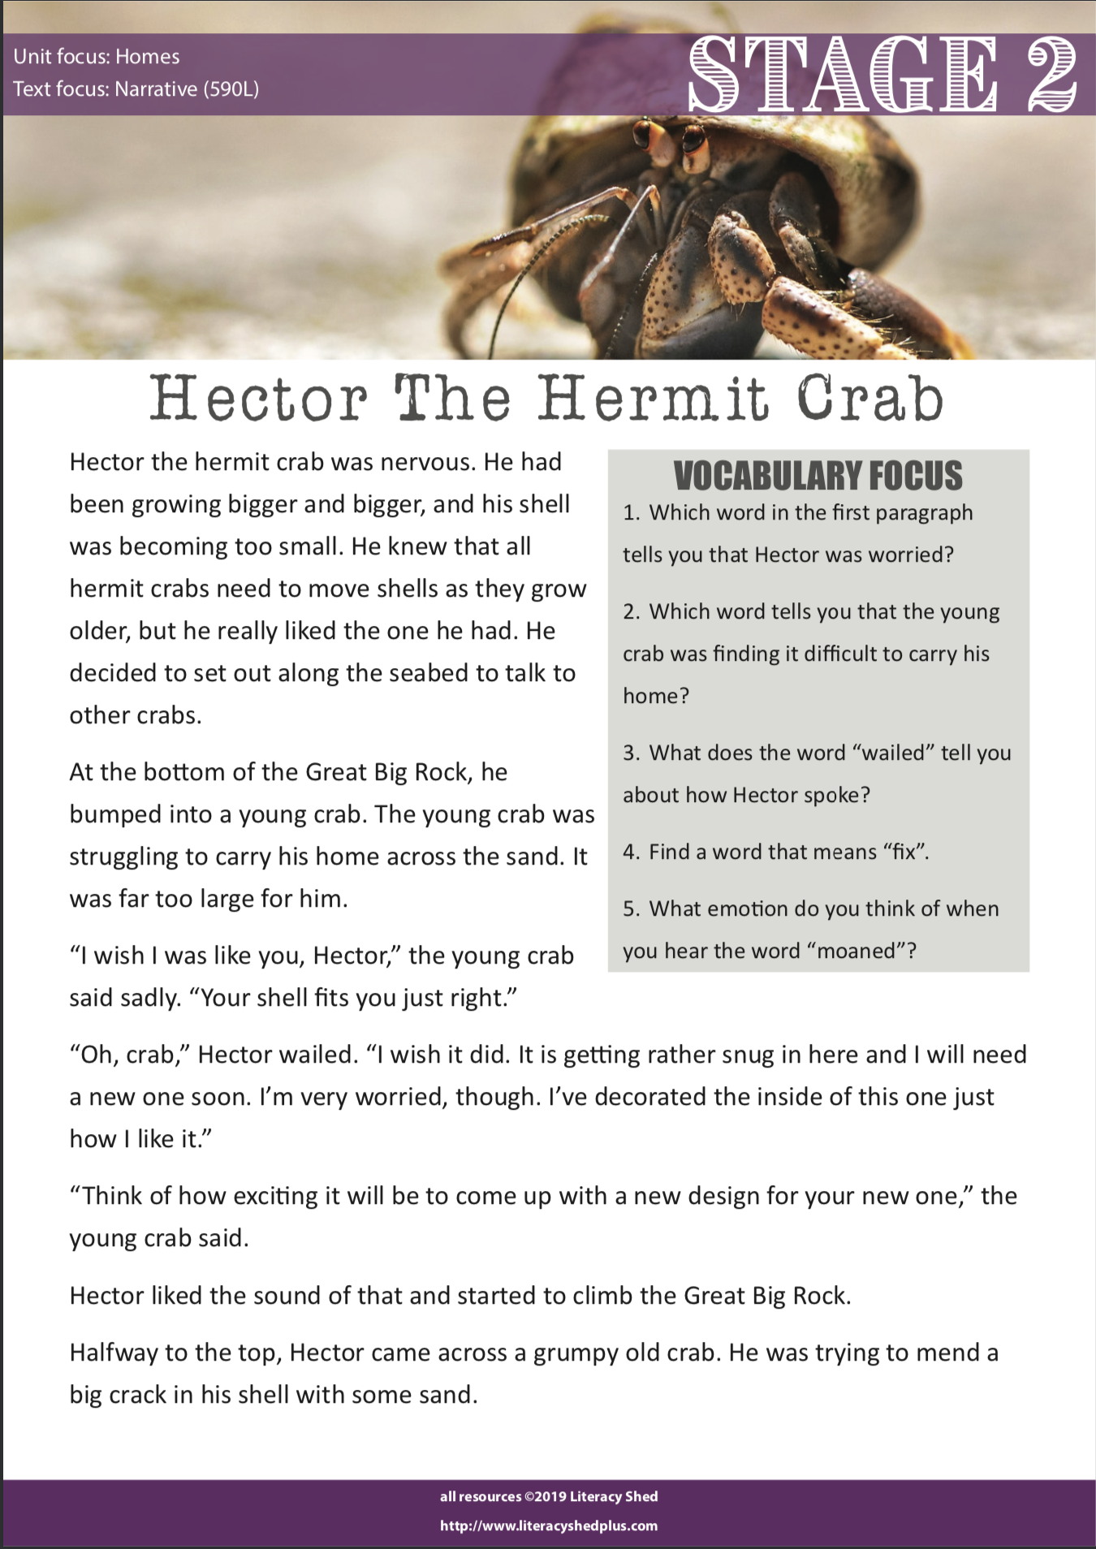

Write your answers here

1.
2.
3.
4.
5.
6.

