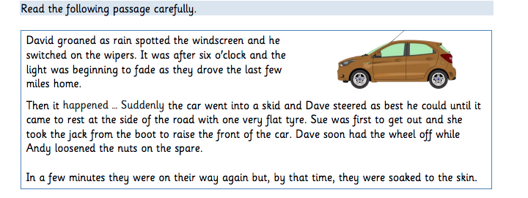

Use your inference and deduction skills to answer the questions and highlight the evidence in the passage to support your answers.

- Was it summer or winter?

- Which tyre was punctured?

________________________________________________________________________

- Had they more than one-wheel spanner?

________________________________________________________________________

- Was there some air in the spare wheel?

________________________________________________________________________

- Was it raining heavily?

_______________________________________________________________________

