Reading

Our Reading leader is Mrs Wilding.
INTENT
At the heart of our curriculum are our school curriculum drivers – Diversity, Responsibility and Opportunities. The drivers shape our curriculum, bring about the aims and values of our school, and respond to the needs of our community. At Moat Farm Junior School, we value reading as a key life skill and as such, are dedicated to enabling all our pupils to become lifelong readers. By the time children leave Moat Farm Junior School, we expect that they have become competent readers who can recommend books to their peers, have a thirst for reading a range of genres including poetry and participate in discussions about books, including evaluating an author’s use of language and the impact this can have on the reader.

IMPLEMENTATION
We believe reading is key for academic success and so we take a holistic approach to the teaching of reading, providing pupils with:
- Guided Reading sessions that focus on the needs of the pupils, using a wide range of different texts, in different genres, which provide the children with the opportunity to demonstrate their understanding and thinking around these.
- A wide range of reading books to read at school and take home to read that can be changed on a regular basis.
- The opportunity to select a book from the school library, to learn to be responsible for this text and return and change it on a regular basis.
- A selection of reading books in each classroom, that are suitable for their reading age; some of which will be directly linked to the class topic. These books provide pupils with the opportunity to apply their reading skills across the curriculum.
- The opportunity to be heard read by a variety of adults in school.
- The opportunity to hear their teacher read aloud, to them, on a regular basis - this may be a book selected by an adult or a recommendation from a pupil.
- A school reading scheme that builds on previous reading experience. The children will work through a series of books that are levelled according to reading ability. These books are taken home and we expect that these books are read with an older member of the family at least 3 times a week, with comments made in the child’s reading record by the person hearing the child read.
- A phonics programme, where necessary, based on the Letters and Sounds programme. This programme encourages the children to blend together sounds they have learnt in order to read words as well as break down sounds within words to spell them. As part of this programme the children can take part in small group sessions where they participate in speaking, listening and spelling activities that are matched to their developing needs.
- Reading planning is personalised to the needs of our children; it challenges them and builds on previous learning.
IMPACT
- At Moat Farm Junior School, we want our reading provision to impact our children in the ways listed below. We want our children to become effective readers, who read fluently and with confidence in any subject. In order to achieve that, our children will show:

- Excellent phonic knowledge skills.
- Fluency and accuracy in reading across a wide range of contexts throughout the curriculum.
- Knowledge of an extensive and rich vocabulary.
- An excellent comprehension of texts.
- The motivation to read for both study and for pleasure.
- Extensive knowledge through having read a rich and varied range of texts.

We monitor the impact of our reading provision through half termly whole school pupil perceptions, termly assessments, lesson observations and monitoring of reading books.

World Book Day
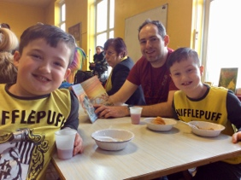
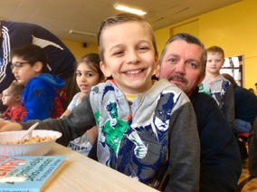
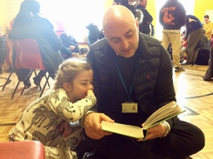
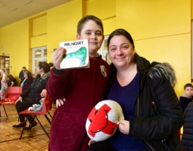
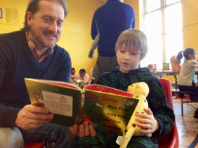

During this year’s World Book Day, children held a ‘Booky Breakfast Event’! Children arrived at school with their favourite book, dressed in their pyjamas and had breakfast at school with their friends and family. During the morning, we read and shared our favourite books, while having breakfast and raising money for Book Aid International! Well done everyone!

