Phase 5 Phonics Week 14 Monday ey

You will need a pen or pencil and some paper to write on.

Here’s the video from The English Hub

https://www.youtube.com/watch?v=ElPAaYAjpxE&feature=youtu.be

Today’s activity is from phonics play

https://www.phonicsplay.co.uk/resources/phase/5

Click on Dragon’s Den
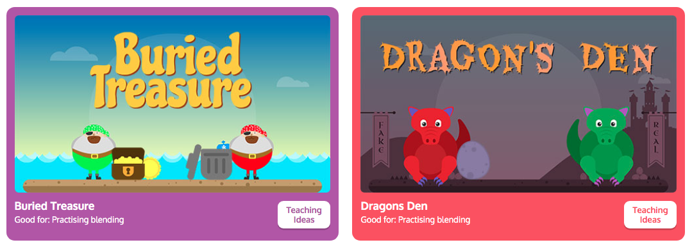

Click on Phase 5
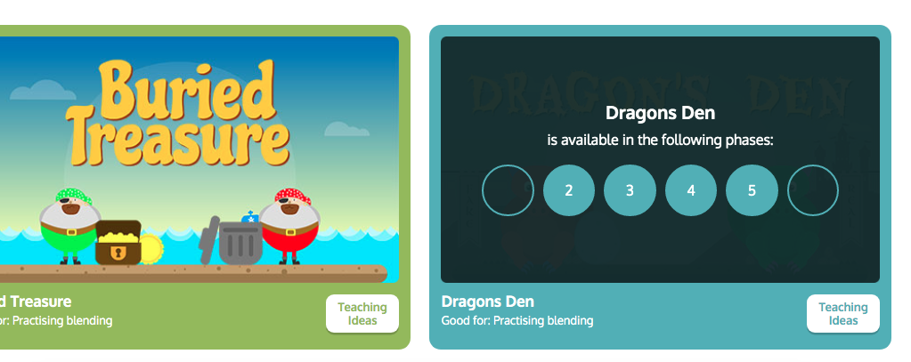

This page tells you what you need to do in the game – when you are confident with what you need to do click Start
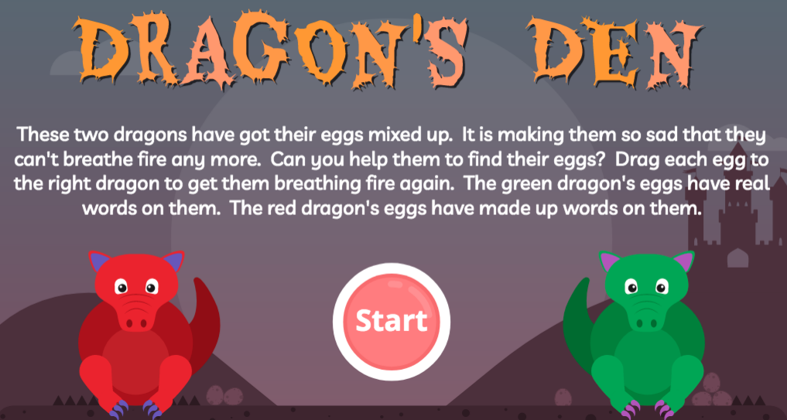

Then click phase 5
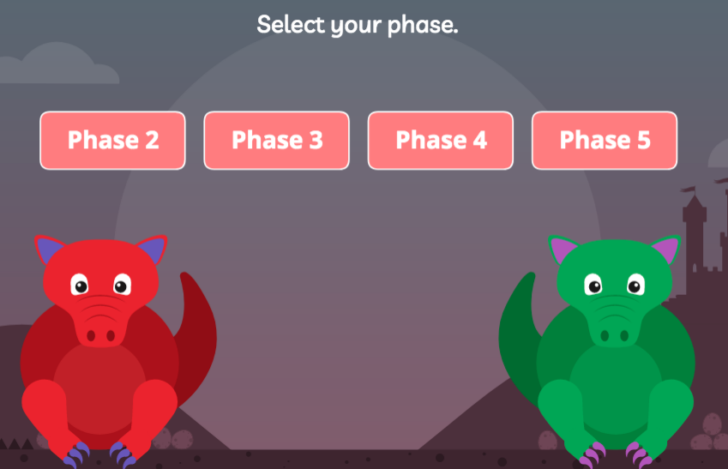

Click ey
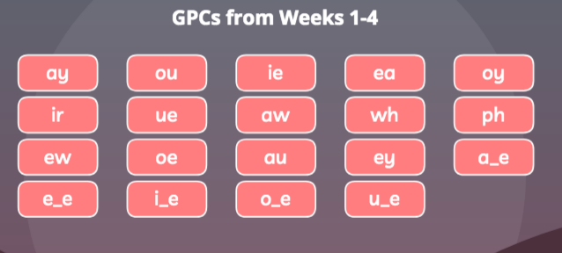

Now put the egg to the correct dragon – if the word is a real word it needs to go to the green dragon, if it’s a made-up word then it needs to go to the red dragon.
