Phase 5 Phonics Week 13 Friday ai alternative spelling

You will need a pen or pencil and some paper to write on.

Here’s the video from The English Hub

https://www.youtube.com/watch?v=G_KDZ6YndSU&feature=youtu.be

Today’s activity is from phonics play
https://www.phonicsplay.co.uk/resources/phase/5/alt-spellings-ai

Click start
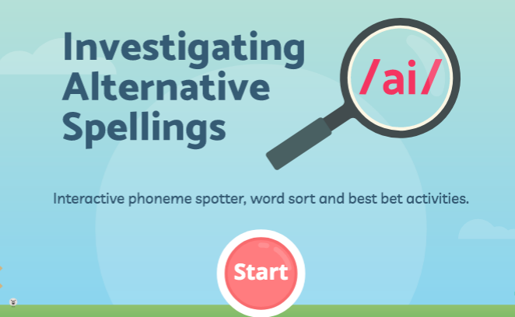

Then click phoneme spotter
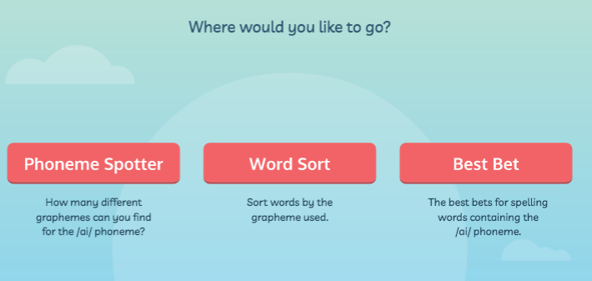

Read the newspaper article and work out how many ‘ai’ sounds there are in the text.
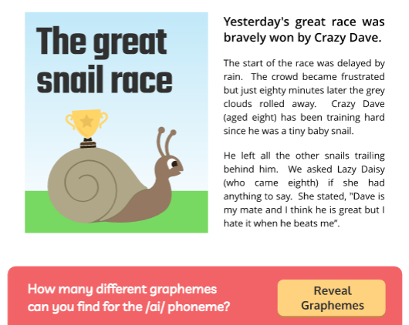
When you think you have found them all press ‘Revel graphemes’ and it will show you all the answers.

