Phase 3 Phonics Week 14 Monday ow and oa

You will need a pencil or pen and something to write on

Here is today’s video
https://www.youtube.com/watch?v=AQI_d8hgAVI&feature=youtu.be

Today’s activity is from phonics play

https://www.phonicsplay.co.uk/resources/phase/3

Click on Buried Treasure
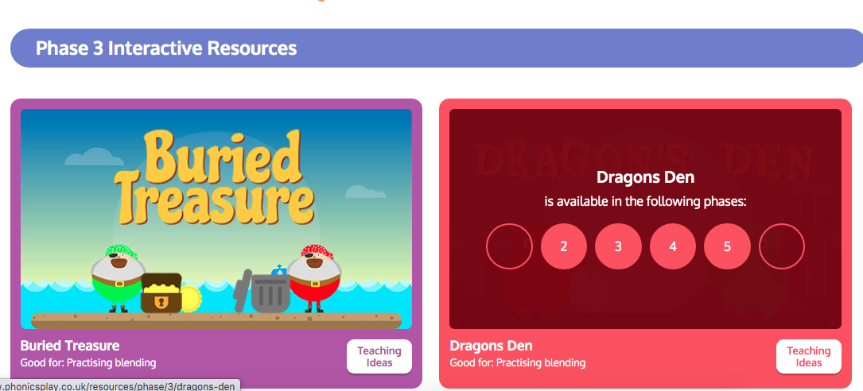

Click on Phase 3
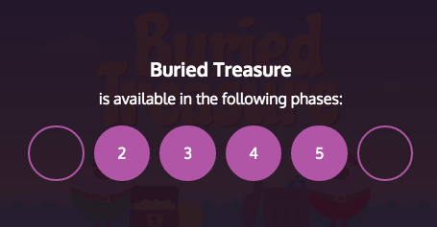

Click Start
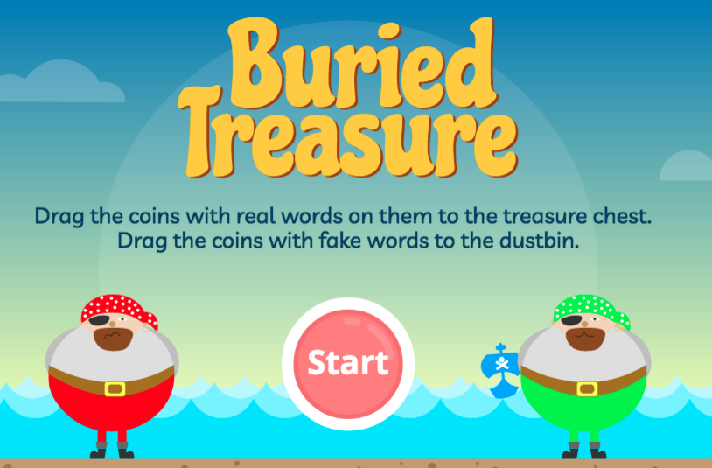

Then click phase 3 again
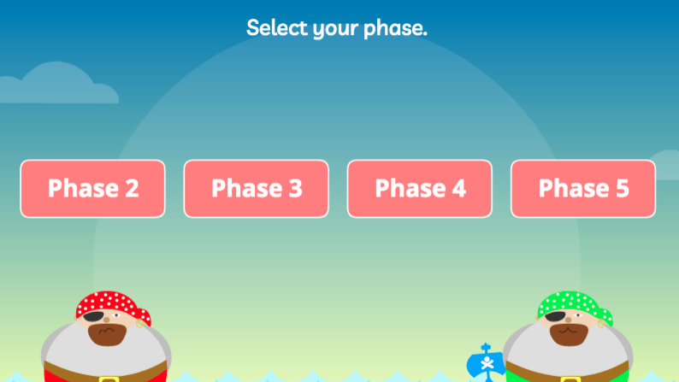

Click +oa
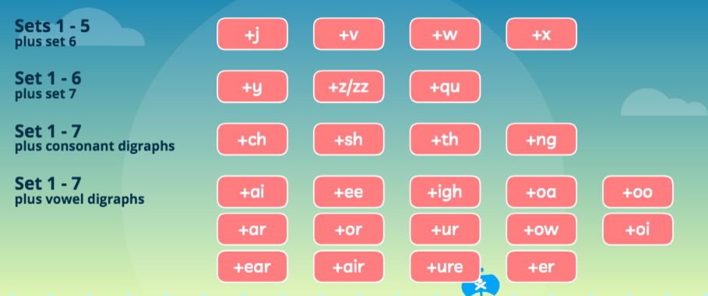

Now put the treasure in the correct place – if the word is a real word it is treasure, if it’s a made-up word then it is rubbish.
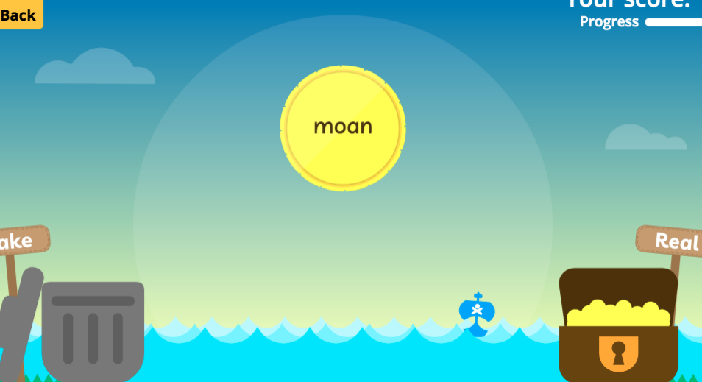

Once you have completed this game – repeat but using +ow

