Phase 3 Phonics Week 13 Friday igh, ee

You will need a pencil or pen and something to write on

Here is today’s video
https://www.youtube.com/watch?v=M5xpt7T3wA8&feature=youtu.be

Today’s activity is from
www.phonicsplay.co.uk

You will need to get your grown-ups to log in with the following username and password. It is free to use and no need to subscribe.

Username: march20
Password: home

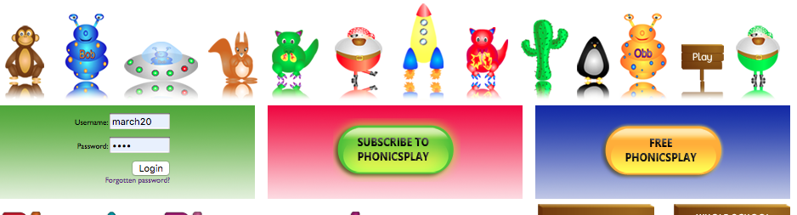

Once you are logged in go to the children’s area
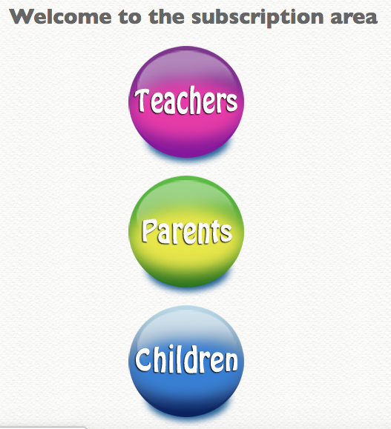

Click on games
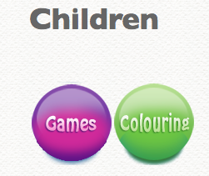
Then go to Phase 3
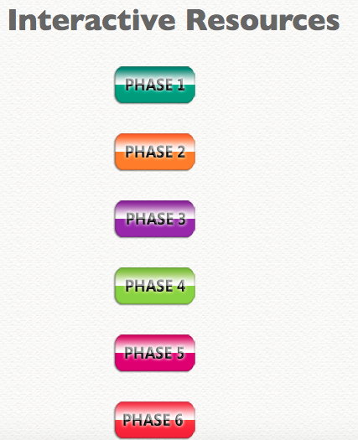

Then go to Grab a giggling grapheme – you may need to scroll down
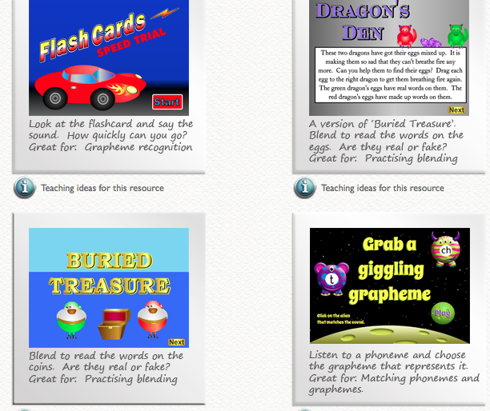

You might get a message that tells you to install a more recent version of flash player, this is ok to do – it is safe and the link is on the screen if you need to.
Click Play
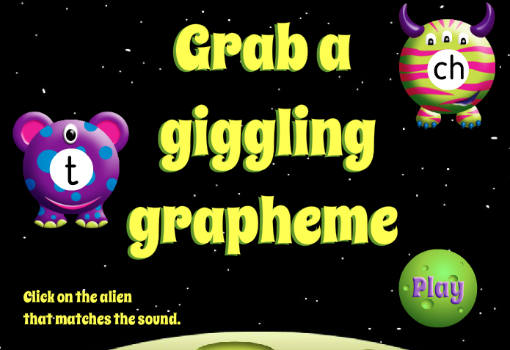

This screen explains that you will need the sound on to complete the activity. Once your grown-ups have read it click anywhere on the screen.
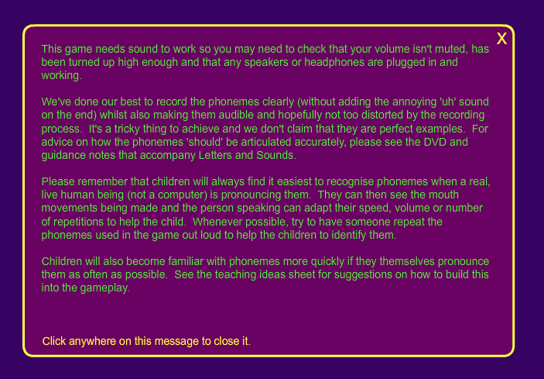

Click more grapheme choices
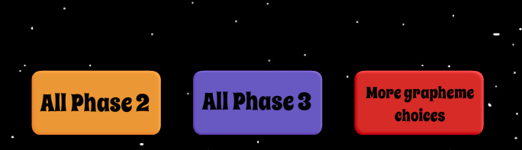

Select +ai, ee, igh, oa
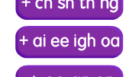

Listen carefully for the sound you need to click on – click on the correct sound
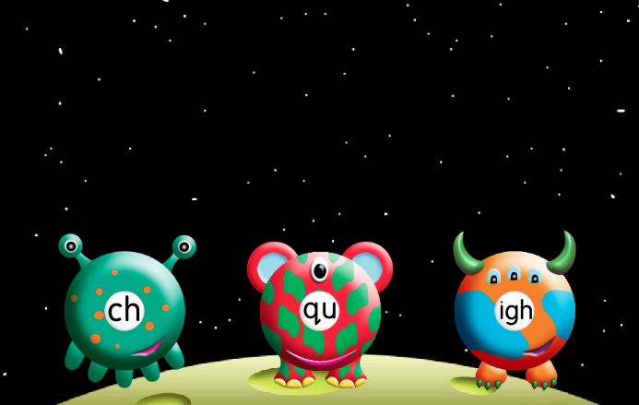

Enjoy!

