Maths – Monday 13th July
L.O: To find equivalent fractions.

- Start by reading the learning reminders below.
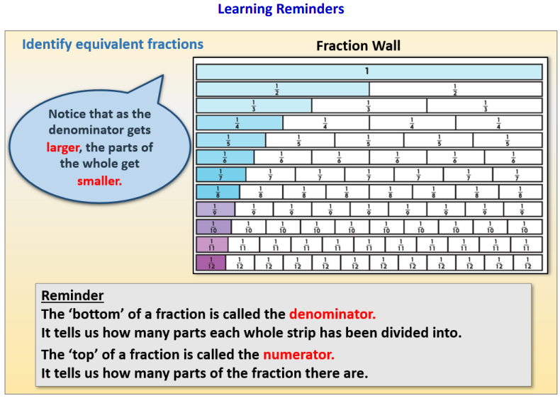

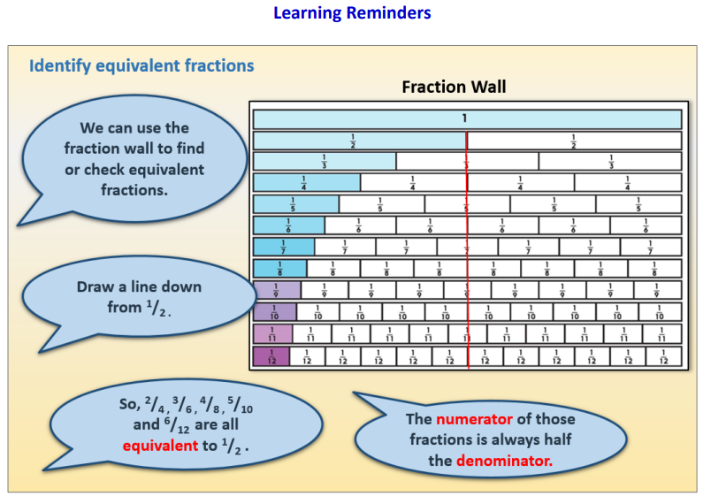

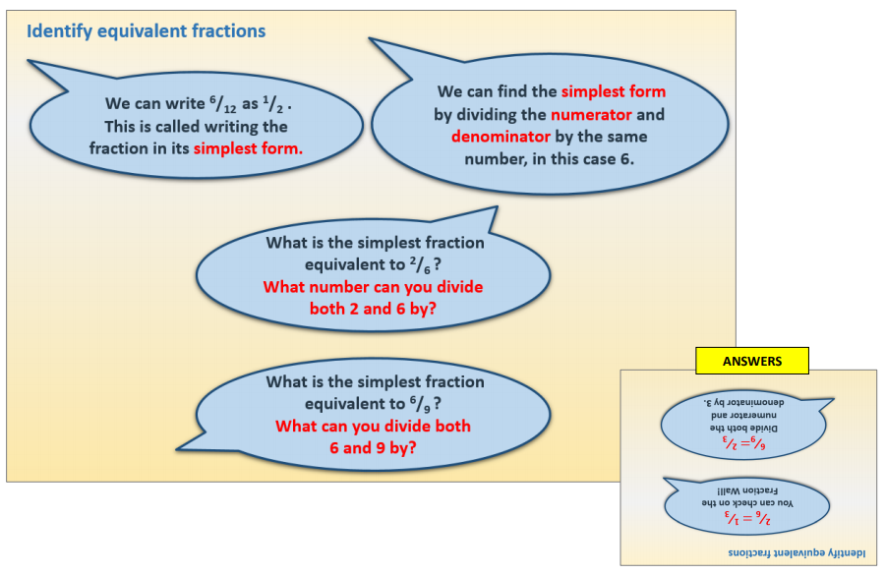
- Have a go at the Maths questions.
There is a choice of mild (easier) or hot (harder) questions. You can choose which one you want to do or have a go at them all.

- If you are finding it tricky, that’s ok. Have a go at the A Bit Stuck sheet with a grown up.
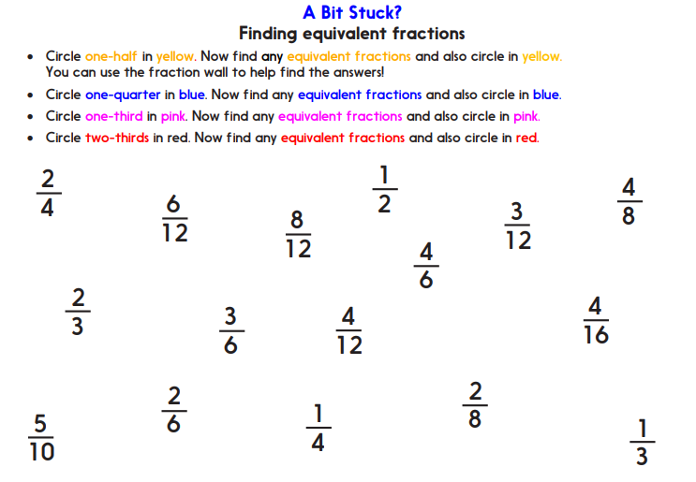
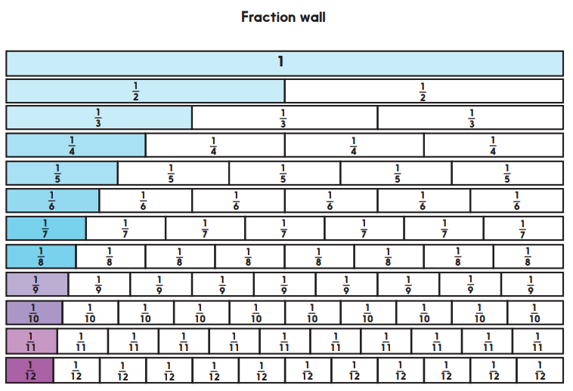

- Think you’ve cracked it? Whizzed through the practice sheets? Have a go at the Investigation.

