Maths questions – Monday 13th July
All the worksheets are in this document – scroll down to the one you want to do OR have a go at them all!

Complete your calculations below or write your answers in the red boxes.
Use the fraction wall in the Maths Year 4 document to help you check your answers.

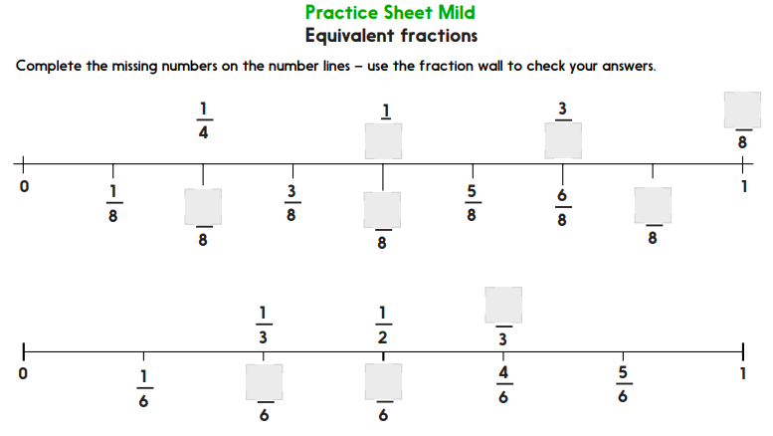

Answers =

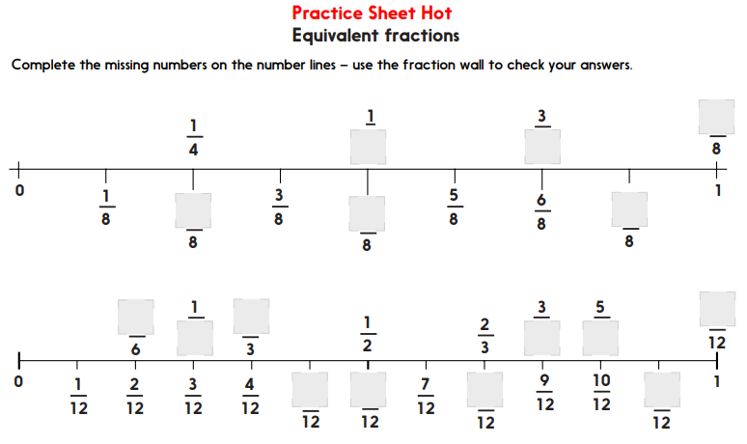

Answers =

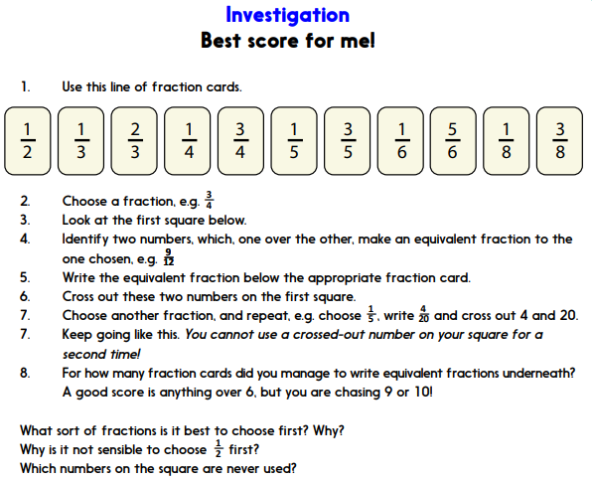
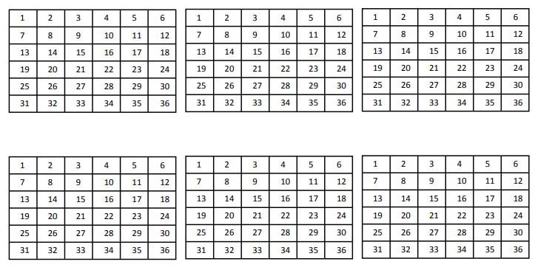

Answers =

