Maths - Friday 10th July
All the challenges are in this document – scroll down to the one you want to do OR have a go at them all! Each one gets a bit more difficult so see how many you can do!
Complete your calculations below.

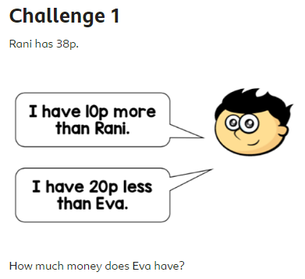
Answer =

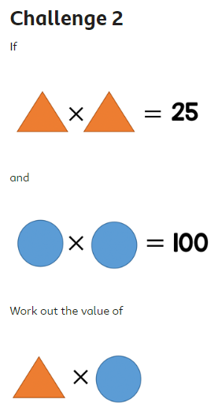
Answer =

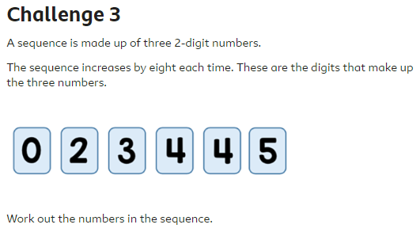
Answer =

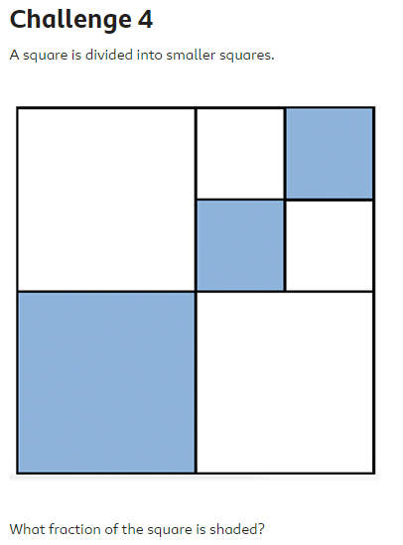
Answer =

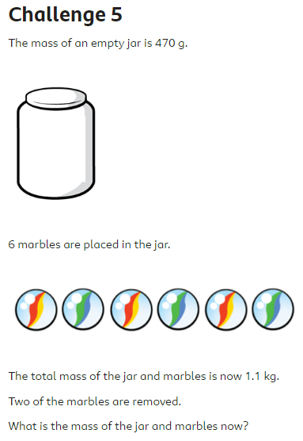
Answer =

