Maths questions – Monday 13th July
All the worksheets are in this document – scroll down to the one you want to do OR have a go at them all!
Complete your calculations below.
Practice Sheet Mild
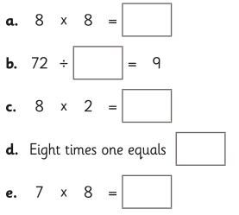
Challenge
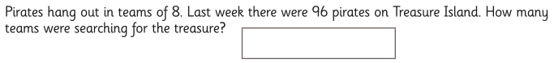

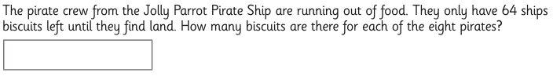

Answers:
a)
b)
c)
d)
e)

Challenge:
1)
2)

Practice Sheet Hot

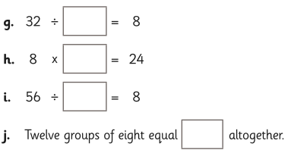

Challenge
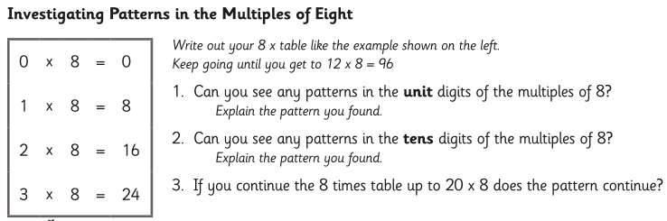

Answers:
g)
h)
i)
j)

Challenge =

