Maths questions – Monday 13th July
All the worksheets are in this document – scroll down to the one you want to do OR have a go at them all!

Complete your calculations below.

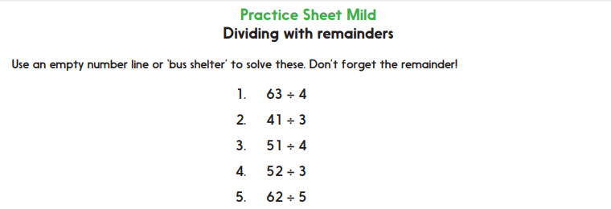
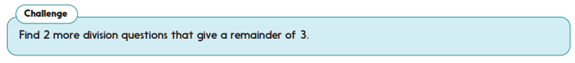
Answers =

Challenge =

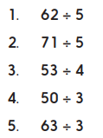
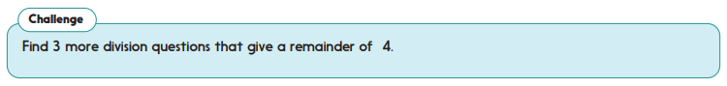
Answers =

Challenge =

