Maths - Friday 10th July

All the challenges are in this document – each one gets a bit more difficult so see how many you can do!

Complete your calculations below.

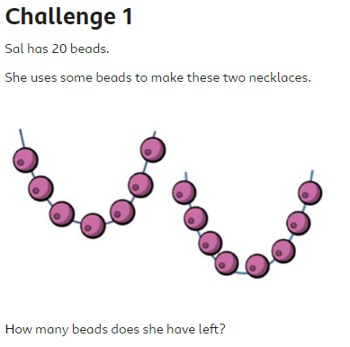

Answer =

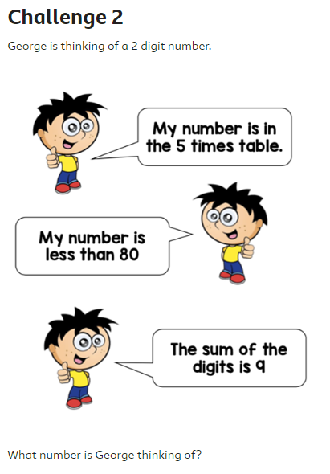

Answer =

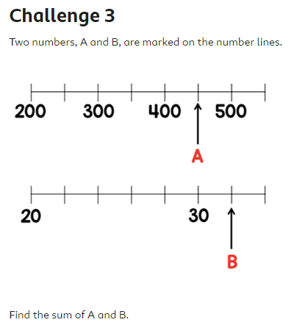

Answer =

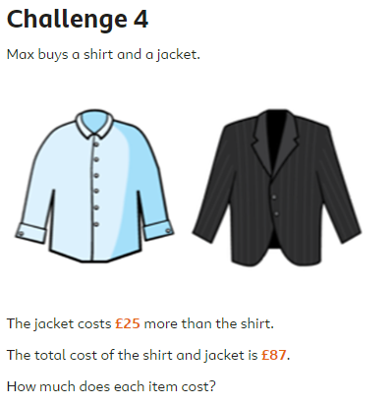

Answer =

Answer =