Maths SEN – Monday 13th July
L.O: To subtract numbers by counting up or counting back.

- Start by reading the learning reminders below.
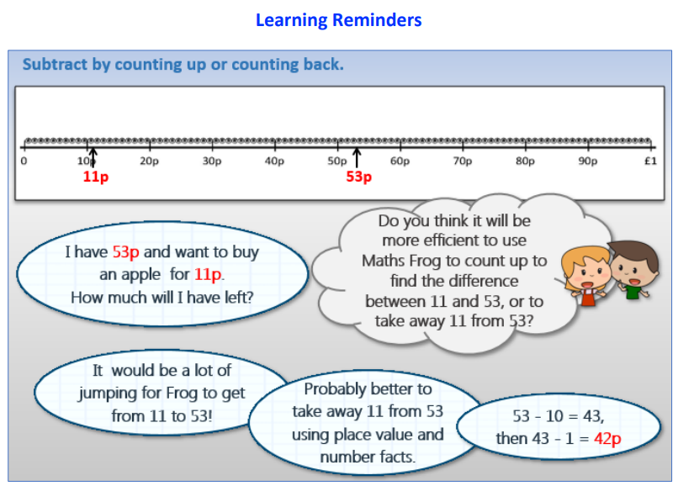

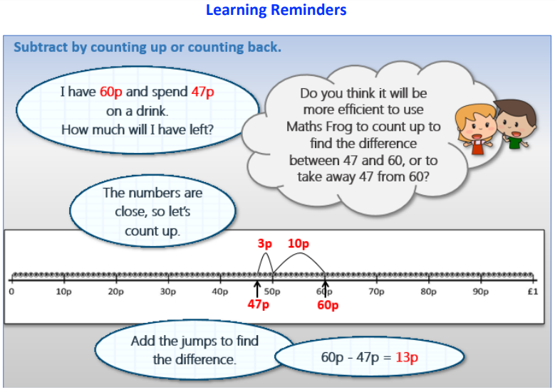

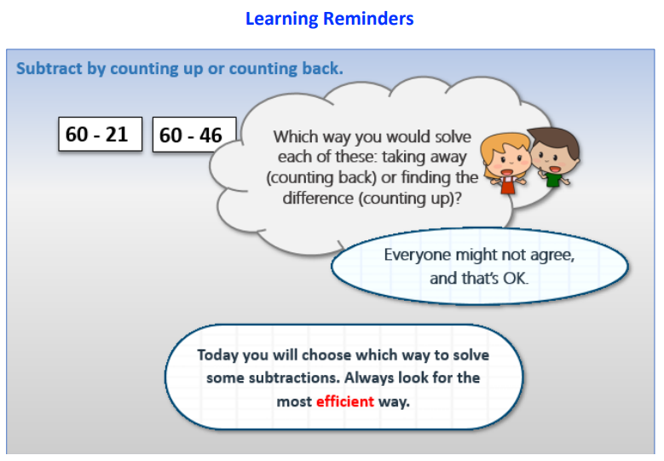

- Have a go at the Maths SEN questions.

