Maths SEN questions – Monday 13th July
All the worksheets are in this document – scroll down to the one you want to do OR have a go at them all!
Complete your calculations below.
Practice Sheet Mild

Use counting up or counting back to work out the answer to these questions. Explain which method you used to work out the answer.

2.
1.

4.
3.

6.
5.

Answers:
1.
2.
3.
4.
5.
6.

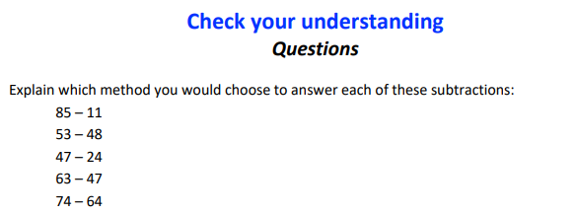
Answers:
1.
2.
3.
4.
5.

