Maths SEN – Monday 13th July
L.O: To count in 5s

- Start by reading the learning reminders below.

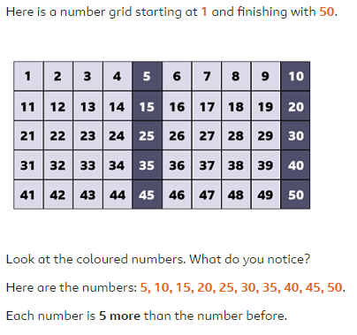
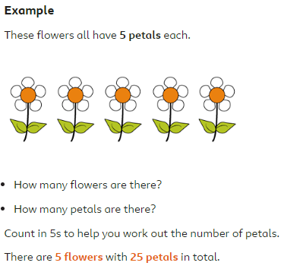

- Have a go at the Maths SEN questions.
There is a choice of mild (easier) or hot (harder) questions. You can choose which one you want to do or have a go at them all.

