Maths SEN answers – Monday 13th July
Practice Sheet Mild
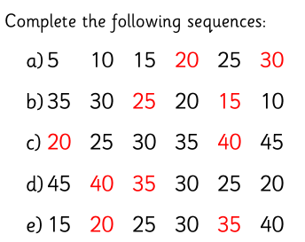
Challenge = 8 x 5 = 40 pens

Practice Sheet Hot
- 2 x 5 = 10
- 4 x 5 = 20
- 5 x 5 = 25
- 6 x 5 = 30
- 7 x 5 = 35
- 12 x 5 = 60
