English – Monday 13th July

1. Story time
Read the Hamilton Story Icarus, by Ruth Merttens and Anne Holm Petersen. If you have read this before, enjoy reading it again and, this time, think about different things – we are exploring the features of myth.

2. Responding to a story
Read and think carefully about the discussion points on Exploring Icarus.
- Record your responses on The Story of Icarus.

Exploring Icarus

1. This is an ancient myth. The characters often represent or stand for qualities in people or particular types of person. They say that Daedalus represents ‘cleverness’ or ‘genius’. What do you think Icarus represents? What does Minos represent?

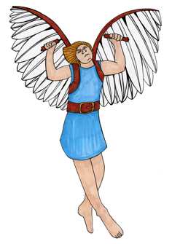
2. How might the story have been different? How else might Daedalus and Icarus have tried to escape. Can you think of another way?

3. Myths explore things that are really difficult for people to deal with. They highlight issues that human beings find hard. What difficult issues do you think are being explored in this story?

The Story of Icarus

1.

2.

3.

3. Retelling the story aloud.
Read each of the Key Plot Points.
- Number each one from 1 to 7 in the order they happen in the story.
- Using the plot points to help you, practise retelling the tale orally.
- Recount the story to your family using your best storytelling voice.

Key Plot Points

King Minos refuses to let Daedalus and Icarus leave, and locks them up.
Daedalus and Icarus make wings to try and escape.
Daedalus and Icarus fix their wings and prepare to leave – Daedalus warns Icarus about flying too close to the sun.
Daedalus builds a maze for the Minotaur at King Minos’s request.
Icarus flies too close to the sun, his wings melt and he falls into the sea.
Daedalus and Icarus are stuck in a tower for years.
Daedalus and Icarus fly away but Icarus doesn’t stick to the plan.

- Describe the monster
On The Minotaur, write a paragraph describing what you think the minotaur looks like. Remember to write in sentences and use powerful adjectives and descriptive phrases.

The Minotaur

Write your description here.

