English – Monday 13th July

1. Make predictions
- Look at the Front Cover. What do you think this story could be about? What could the Night Shimmy be? What might they do?
- Read the First Page. Write down four things that you know about Eric? What can you guess about him? Does he remind you of anyone? What might he do with the Night Shimmy?

Front Cover
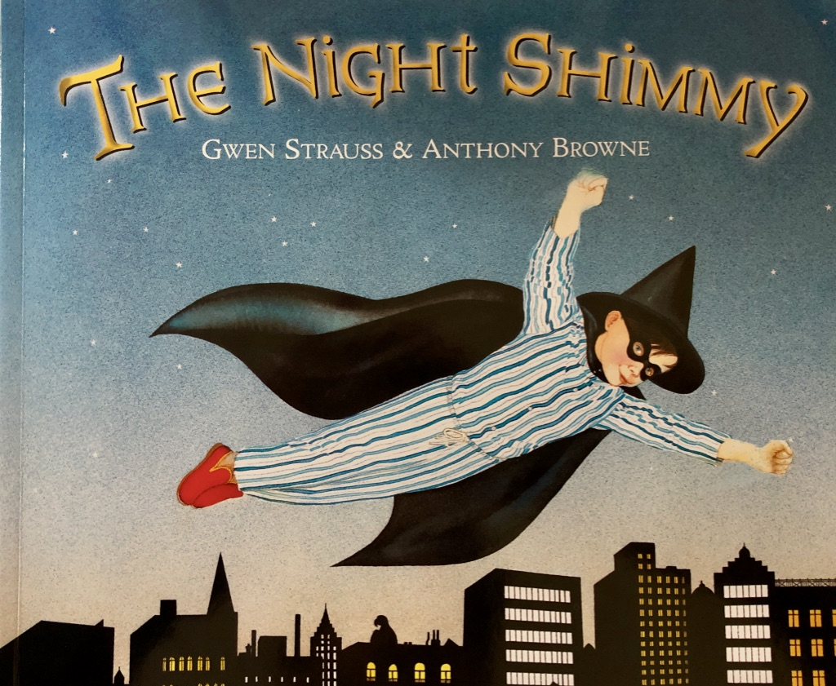

First Page
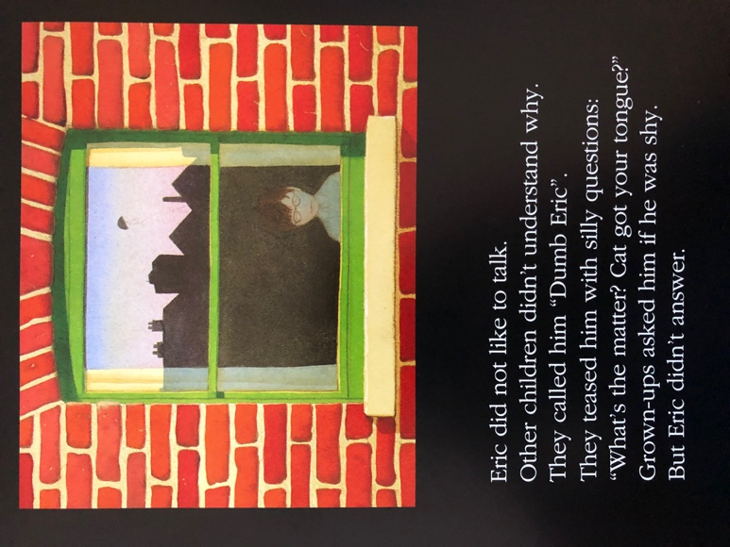
Eric did not like to talk.
Other children didn’t understand why.
They called him “Dumb Eric”
They teased him with silly questions:
“What’s the matter? Cat got your tongue?”
Grown-ups asked him if he was shy.
But Eric didn’t answer.

Write down four things that you know about Eric? What can you guess about him? Does he remind you of anyone? What might he do with the Night Shimmy?

2. Listen to the story
- Listen to the Night Shimmy by Gwen Strauss being read by Ruth Merttens: https://youtu.be/h7ypmw-0JU0
- What do you like about the story? Is there anything that you dislike about it? What did it remind you of? Anything that you have read or seen or anyone that you know? What questions would you like to ask the author?

3. Investigate artwork
- Look closely at Images 1-4.
- Read the Artwork Questions underneath each image. Think about your answers and then write them in clear sentences.

Image 1
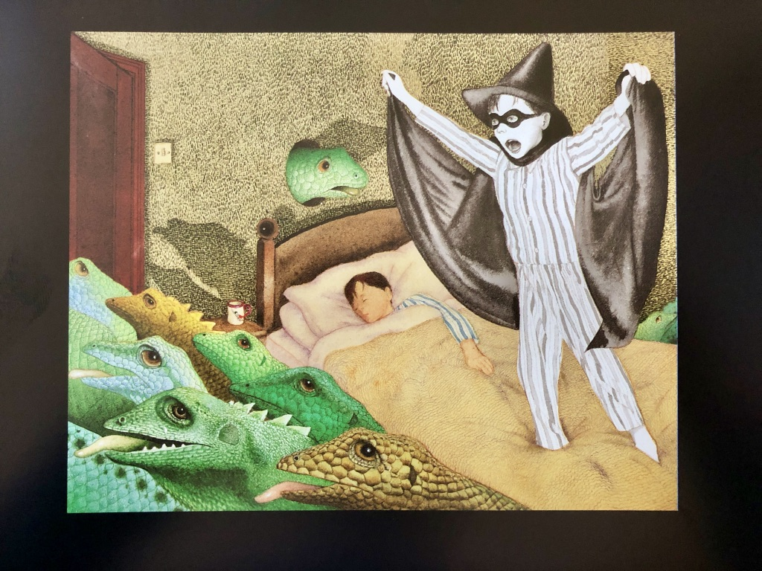
Artwork Questions
Look at Image 1
What is your first reaction to this image? Why do you think you had that reaction?
What do you think is happening in this picture?
Why do you think the Night Shimmy is in black and white?
Image 2
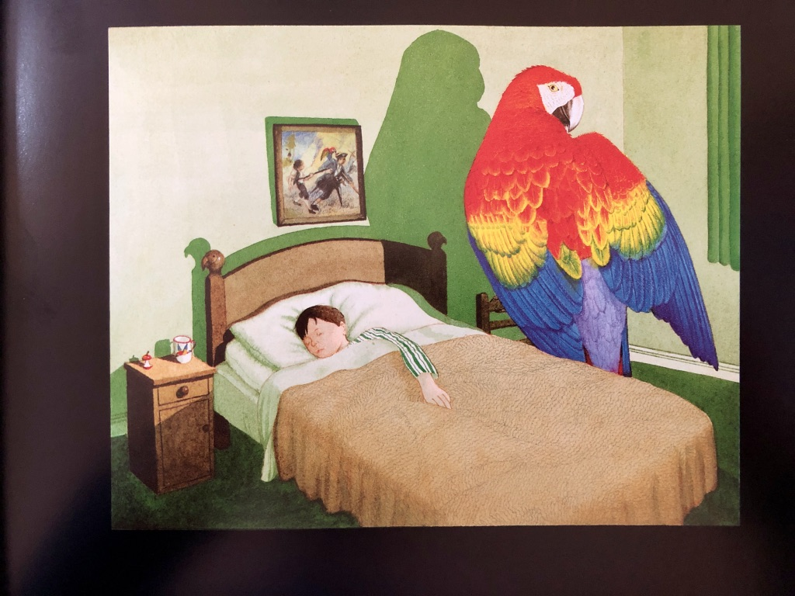
Artwork Questions
Look at Image 2
What adjectives could you use to describe this picture?
Why is there a giant parrot in Eric’s bedroom?
What do you notice about the mug, the top of Eric’s bed and the picture on his wall?

Image 3
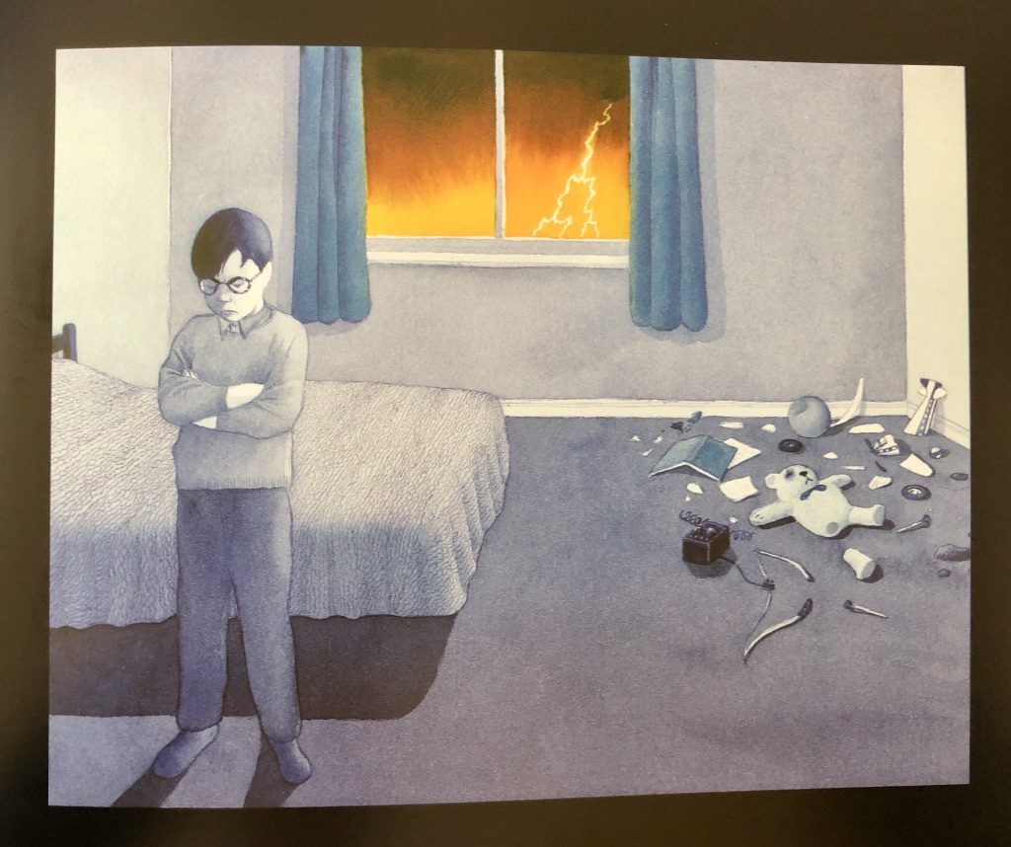
Artwork Questions
Look at Image 3
Why do you think everything is grey and blue apart from the sky through the window?
What emotions do you notice in the artwork?
What do you think Eric might be thinking?

Image 4
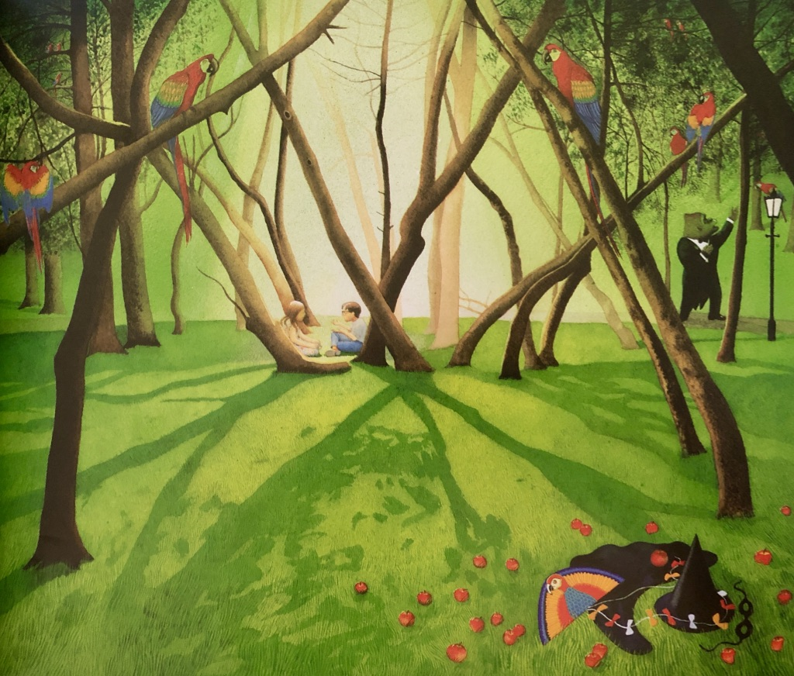
Artwork Questions
Look at Image 4
What can you notice in this picture that someone else might not spot?
Why do you think that all the other pictures have a black frame around them and this one doesn’t?
What do you think Eric and Marcia might be saying?

