English – Friday 10th July

1. Read a draft poem
- Read the Draft Poem that has been written about insulting a Teddy Bear.
- Spot the changes that the writer made when they re-read the poem. How have they improved the poem? Which lines in the poem do you like best? Why?

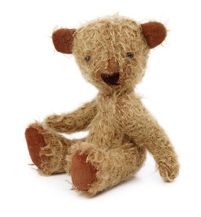
DRAFT POEM - Insulting a teddy bear

You!

You!
You would lose your ears if they weren't stuck stitched to
your head.
You!
You bore me with your [endless] chatter about honey and
bees.
You!
You are as lazy as a cat, stretched out in the summer's sun.

You!
You sit there like a [saggy] sack of potatoes, sat slumped in
the corner.
You!
You never help me tidy my room.

You!
You are as useless as a dried up felt tip.

[additions on re-reading] amendments on re-reading

2. Write your own insult poem
- Decide what you will insult. Make it a toy or an object not a person!
- Use the Planner to write down ideas for insults. You can use some of the ideas in the teddy bear poem or from yesterday’s poems. Write your ideas in the red boxes.
- Choose your favourite ideas and put them in a good order for a poem.
- Read your poem through and make changes to improve it.

Planner

Insulting...
You are as lazy as a cat, stretched out in the summer's sun.
Prepositions: with, of, by, from, on, under, below, between, inside, next to, over, by, in, against

Insult Poem
Write your own insult poem here.

