English – Monday 13th July

1. Explore the front cover and first page of a book
- Look closely at the Front Cover of The Paradise Garden.
- Read and look closely at First Page. Use a thesaurus (book or online www.thesaurus.com) and complete First Page Noises.
- Make predictions. How do you think this story will develop?

Front Cover

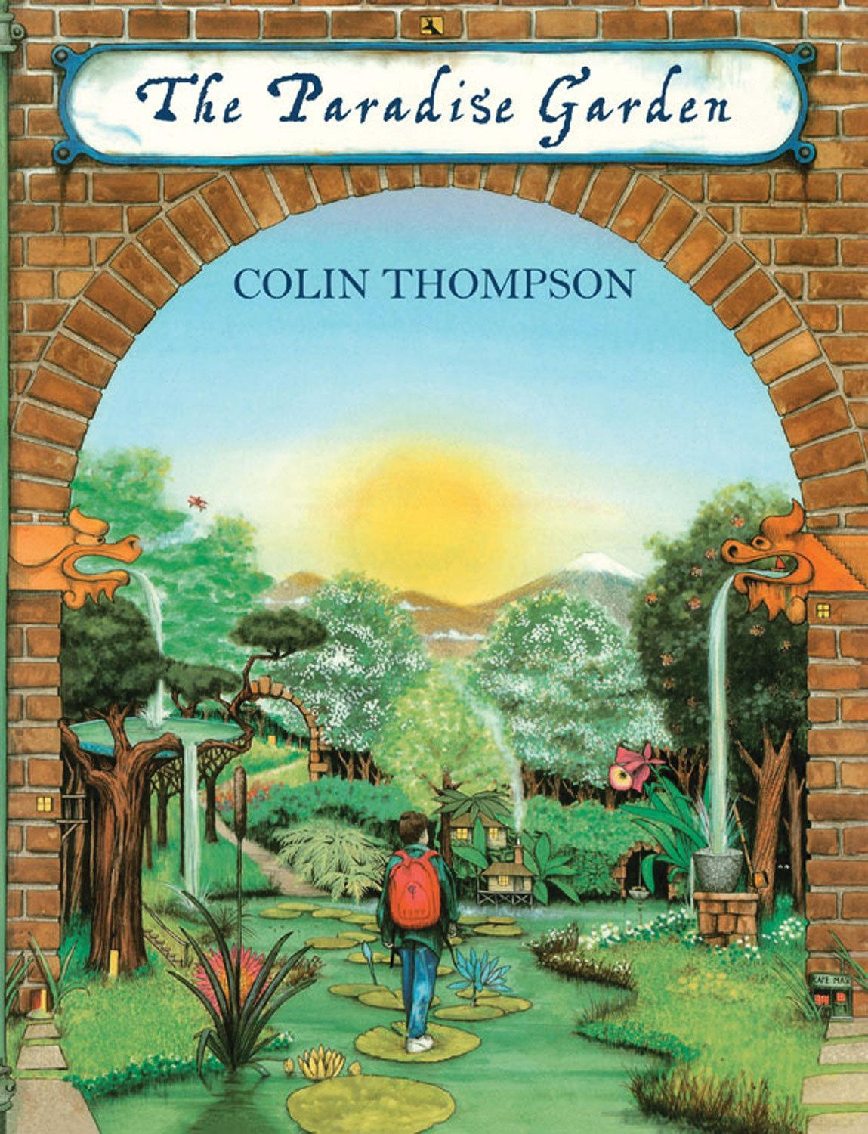

First Page
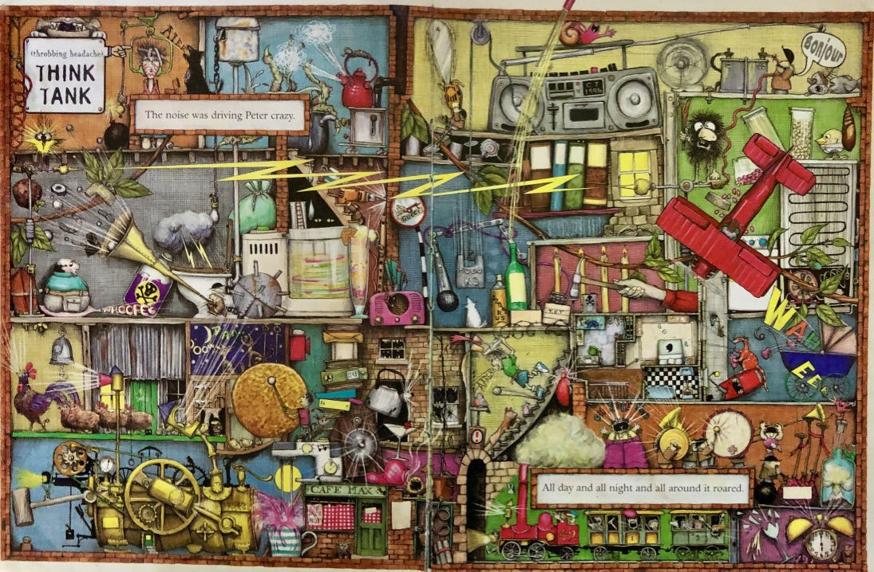
First Page Noises
Write possible vocabulary for the sounds each object from the first page makes.
Choose an object from the page for the last row and write the sounds it makes.
Find vocabulary with a book or online thesaurus. https://www.thesaurus.com/

Object | Possible vocabulary
Kettle | whistled, fluted, piped, shrieked, tootled, hissed, wheezed
Engine  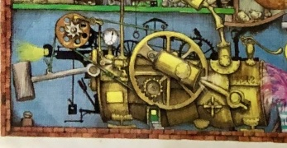 | reverberated
Drums
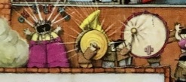

2. Listen to the story and answer questions
- Listen to the reading of the story: https://youtu.be/6pzhlQ_cupg
- Read Questions and think about your answers. Write them as full sentences. You can use The Paradise Garden – Text to help.

Questions

- Why do you think that Peter decided to run away?
- What plan did he have to make sure no one would miss him?
- What difference does it make to Peter when he is in the garden?
- How did Peter manage to eat when he was in the garden?
- What made Peter realise that he was lonely?
- Why do you think that Peter decided to go home?
- How was life the same and how was it different now?
- Why do you think that the garden was the place that Peter decided to run away to?

The Paradise Garden – Text

The noise was driving Peter crazy.
All day and night and all around it roared.

Only in one place was there any peace. In the west of the city was a fabulous garden. There, behind its tall walls and thick trees it was possible to escape the noise. For Peter, who had lived all his life in narrow streets, it was the closest place to paradise he had ever seen.

Surrounded by trees from around the world, were quiet lawns and secret places that felt like the middle of the country, where the grass was long and squirrels buried acorns under the bushes. If you shut your eyes you could still hear the traffic but it felt far away and unimportant. The air smelt clean with a breath of trees. Hidden by thick bushes, Peter lay on the grass and floated away into the deep forest | 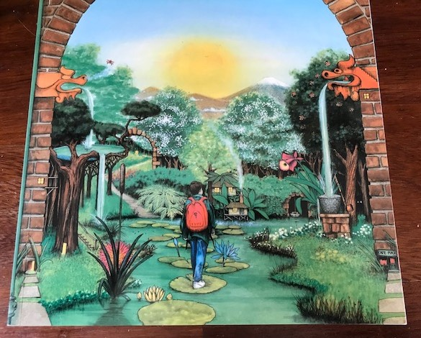

He’d planned his escape so no one would miss him. It was simple. He told his mother he was going on holiday with his father. She was annoyed, but not enough to stop him, not enough to phone his father.

That night Peter slept beneath the stars. The city had dropped to a faint murmur. Foxes hunted through the garden and owls called out in the dark. No monsters visited Peter’s dreams that night. There were no nightmares of running through slowed down time, just peaceful empty sleep.

The first weeks were wonderful. He thought he might get fed up with the garden, that maybe its magic would wear off, but it didn’t. He thought about his sister and his friends. He thought about is parents fighting and his father walking out. It all seemed so far away. It was as if the garden wall were a boundary to another world.

He bought food in the cafes and washed his clothes in a lotus pond among tall bamboos.
And as he went through the garden, he collected things: a gold ring, a red balloon and apocketful of seeds. And when it rained, there were other great glass houses. Beneath their crystal skies it was forever summer. At night Peter crept into the Palm House to pick bananas and exotic fruits from around the world.

He grew to know every part of the garden, from quiet forgotten pathways where lovers walked to white paths of bright flowers where old ladies sat and painted. He grew to know the animals to. At home he had never been allowed a cat or dog or even a fish but here he had dozens of friends.

Eventually his money and the bananas ran out and he had to live on other people’s leftovers. But even then he was happy. No one shouted at him. No one told him he was stupid. No one tried to make him do things he couldn’t. And no one made him face up to the fact that he would have to go home one day.

Life was so peaceful. At night he climbed the tallest tree and looked out at the distant city sparkling like fallen stars. He walked between tropical palms and swam with brilliant goldfish in a pool of giant waterlilies.  In a corner of the garden, behind tall brick walls, was the only house where people lived. Peter stood in the shadows | 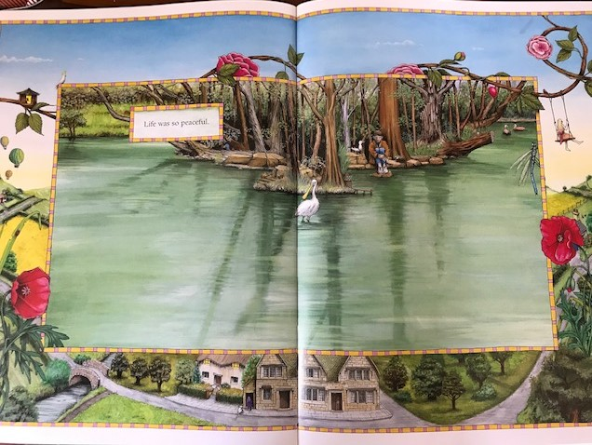
by the window and watched the family inside. A fire burned in a grate, turning the room into gold. Two children played cards on the floor while their parents watched television and, on the carpet, an old dog dreamed of its youth. Peter felt a terrible sadness in his heart, a deep loneliness that he realised had been there all his short life.

Summer grew weary. Everything slowed down and stopped growing. A fine dust covered the leaves. The flowers turned their heads onto the ground and Peter felt lonely. The leaves turned gold and began to fall and Peter knew it was time to go home.

In the yard behind his house Peter planted all the seeds he had collected. Nothing at home had changed. The noise still went on day and night. His mother shouted, the neighbours shouted and the city roared. But now he had his own paradise garden, and he knew that he would always have one wherever he went.

