English SEN – Monday 13th July

1. Story time
Read the information on Quest Stories.
Go to https://www.youtube.com/watch?v=cRAAQ8EWzig.
Listen to the reading of Lost and Found, written by Oliver Jeffers.

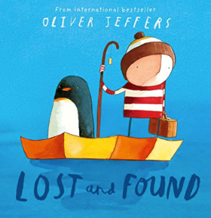
Quest Stories

In a moment, you are going to listen to a reading of Lost and Found by Oliver Jeffers. Lost and Found is a quest story.

In quest stories, characters undertake a special journey in order to reach a destination or to achieve something that really matters to them.

The characters must overcome challenges or obstacles before they finally achieve their goal.

Often the characters learn something important about life while they are on their journey.

Quest stories often have three parts –
- a beginning where things are normal until a strange event takes place;
- a middle section where the journey begins;
- an end section where characters look back on their journey and think about what they have learned.

As you listen to Lost and Found, think about these questions:

- Which characters in the story go on a quest?
- What is the destination and purpose of their quest?
- What challenges or obstacles do they have to overcome before they reach their goal?
- What do they learn about life as they travel?

2. Sequencing a story
Look at the Story Sequence Cards.
- Read each of the cards and place them in the correct order, so that they tell the story of Lost and Found.
- Number the cards from 1 to 10 in the order they happen in the story.

Story Sequence Cards

They push the boat out to sea and travel for many days. The boy tells the penguin stories as they go. There is calm and stormy weather. | The boy and penguin arrive at the South Pole. The boy is pleased but the penguin is quiet. The penguin gets out and watches as the boy rows away.
The boy feels strange on his own. He realises that the penguin was not lost but lonely. The boy decides to row back to the South Pole (he doesn't notice the penguin sailing past the other side of the iceberg). | The boy rows sadly towards home. He doesn't tell any stories as he has no one to listen to them. He spots something in the distance. He gets closer until he can see it is the penguin.
The boy arrives back at the South Pole. He looks for the penguin everywhere but can't find him. He sadly leaves again for home. | The boy takes his row boat out. They test it for size and strength. They pack what they need for the journey.
The boy discovers that penguins come from the South Pole. He asks a ship to take them there but can't make his voice heard. | A penguin arrives at the boy's door. The penguin follows the boy everywhere. The penguin seems sad. The boy thinks he is lost.
The boy and penguin hug.  They travel back home, talking about wonderful things on the way. | The boy tries to help the penguin find his way home. He asks at the Lost & Found office, asks some birds and his toy duck but no one helps. The boy can't sleep at night.

3. What are characters thinking?
Look at the picture from the story.
Think about where in the story this picture is from: what is each character feeling at this point in the tale?
- Use the two Thought Bubbles to record each character’s thoughts in full sentences.
