English SEN – Monday 13th July

1. Rhyme time
Go to https://www.bbc.co.uk/teach/school-radio/nursery-rhymes-hickory-dickory-dock/znpj47h
Listen to the traditional rhyme, Hickory Dickory Dock.
- Listen again, joining in with as many of the words as you can.

2. Transcribing and learning a traditional rhyme
Copy out Hickory Dickory Dock in your best handwriting.
- Add some pictures.
- Start to learn the rhyme off by heart.

The words to
Hickory Dickory Dock

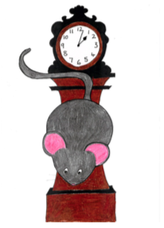

Hickory Dickory dock!
The mouse ran up the clock.
The clock struck one,
The mouse ran down,
Hickory Dickory dock.
I saw him when he ran down!

3. Comparing rhymes or poems
Read the poem No Hickory, No Dickory, No Dock by John Agard.
Look at the statements on the Comparisons chart.
- Think about Hickory Dickory Dock and No Hickory, No Dickory, No Dock.
- Put yes or no against each statement.

No Hickory, No Dickory, No Dock
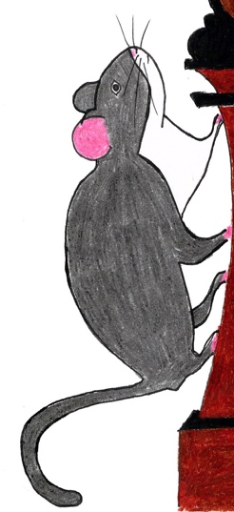

Wasn’t me
Wasn’t me
said the little mouse
I didn’t run up no clock

You could hickory me
You could dickory me
or lock me in a dock

I still say
I didn’t run up no clock

Was me who ran under your bed
Was me who bit into your bread
Was me who nibbled your cheese

But please please,
I didn’t run up no clock
no hickory
no dickory
no dock.

by John Agard

From The Puffin Book of Fantastic First Poems, edited by June Crebbin,
Puffin Books.

Comparisons

 | Hickory Dickory Dock | No Hickory, No Dickory, No Dock
Has a clock in it
Has a girl with an extra line in it
The clock strikes 1 in it
Has pairs of words that rhyme in it
Has a ‘sing song’ rhythm to it
Is a really well-known traditional rhyme
Is funny

Which do like more, Hickory Dickory Dock, or No Hickory, No Dickory, No Dock?
Write a sentence saying why you like that version more.

Write your answer here.

